**PEDAL PROOF**

**Bicycle Accident Prevention Project.**



**GROUP 8**

**Data Engineering Group Members**

Yogesh Meka

Teja Sai Srinivas Kunisetty

Divyasree Pithani

Siva Karthik Sangaraju

Pranavi Battula

Sai Bhargav Dasaraju

Contents

|  |  |
| --- | --- |
| Mail | 3 |
| Screenshots | 4 |
| Phase 1: GCP Setup | 4 |
| Phase 2: OpenRefine | 8 |
| Phase 3: Hive Table Creation | 12 |
| Phase 4: SparkSQL Queries | 15 |
| Phase 5: BigQuery Advanced Analysis | 23 |
| Key Findings | 31 |
| Possible Solutions | 32 |
| Conclusions | 32 |
| Meeting Notes | 33 |
| References | 35 |
| Bonus 36 | |

# Mail

**To**: Pedal Proof Bicycle Accident Prevention Project Team (PPBAPT)

**Cc**: Schenita Floyd, US Community Leaders  
**Bcc**: Yogesh Meka, Teja Sai Srinivas Kunisetty, Divyasree Pithani, Siva Karthik Sangaraju, Pranavi Battula, Sai Bhargav Dasaraju  
**Subject**: US Bicycle Crash Data Project Overview

Dear Colleagues,

In our neighborhood, we have come across the problem of multiple reporting’s of cyclist crashes which are increasing over time, to mitigate the risks that come along, and to ensure the safety of our residents, we developed this pedal proof project.

The data infrastructure for the Pedal Proof Bicycle Accident Prevention Project has been set up by the data engineering team and is now ready for analysis and insights development.

We have explored multiple datasets from legit public warehouses like data.gov, pedbikedata.org etc., in order to find the high-quality datasets required for the project. After a rigorous search, we found three datasets that satisfy our requirements. Once the data sources have been finalized, we have cleaned the data using OpenRefine software. This included the removal of extra columns, renaming fields for simplicity, type changing of text fields such as total injuries, deaths, and age to numeric, and outlier correction for analytical accuracy.

After processing the data, we imported the data into Hive as an external table (bicycle crashes) within a safe, scalable cloud environment, Google Cloud platform (GCP). We have performed preliminary exploratory data analysis using HiveQL, PySpark SQL and even done some experimentation in BigQuery.

The data is now in complete custody and ready to be analyzed further in depth, visualized, and interpreted. We have provided the screenshots below that are needed to explain our recent developments so that you can go on with the remaining of the subsequent steps in this project's data cycle smoothly.

Please do not hesitate to call us should you have questions answered or need access assistance. We value the feedback this effort will create toward bicycle safety improvement in our area.

Sincerely,

Yogesh Meka, Teja Sai Srinivas Kunisetty, Divyasree Pithani, Siva Karthik Sangaraju, Pranavi Battula, Sai Bhargav Dasaraju

PPBAPT  
Data Engineering Team

# Screenshots

## Phase 1: GCP Setup

Screenshot 1 — Project Creation on GCP – Karthik

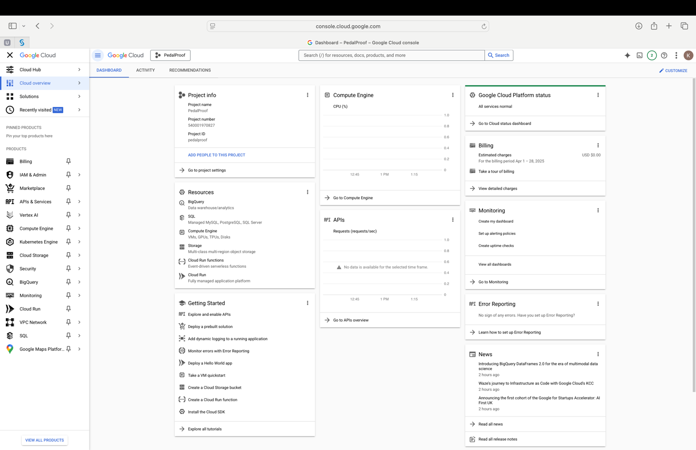

Screenshot Owner: Siva Karthik

Application Used: Google Cloud Platform

Tasks Performed:

* Developed a new GCP project for the analysis of bicycle accident prevention.
* Enabled the BigQuery, Cloud Storage, and Dataflow APIs that are necessary for processing and ingesting data.

Screenshot 2 — Dataproc Cluster Setup - Pranavi

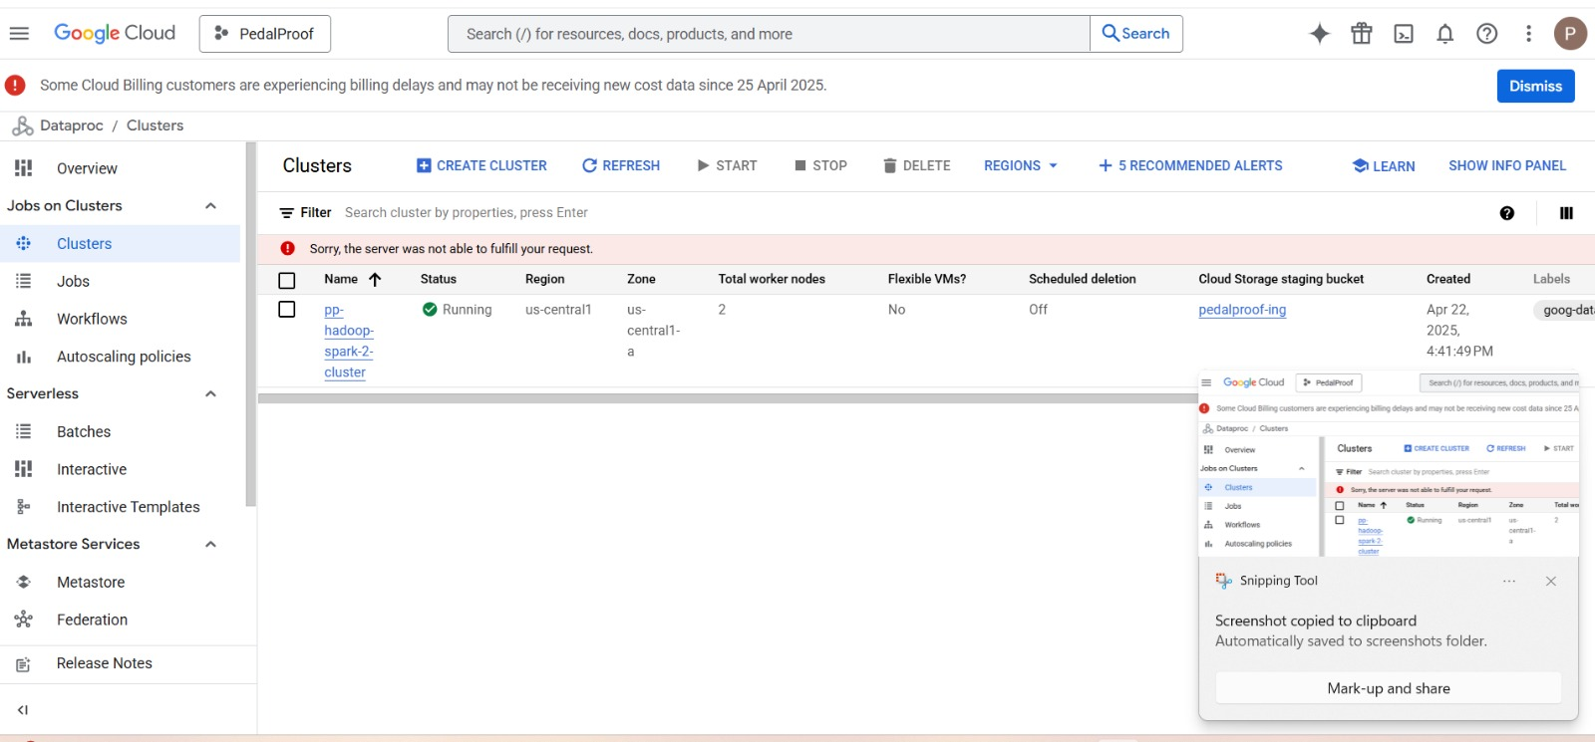

Screenshot 3 — Hadoop File System (HDFS) Setup (VMware instances) – Pranavi

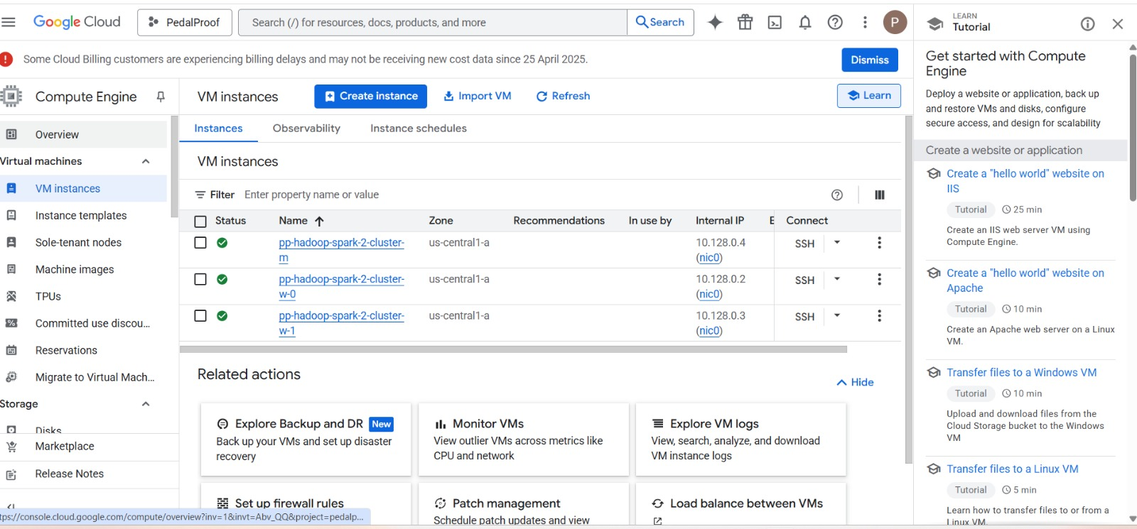

Screenshot 4 — Storage Buckets Created – Karthik

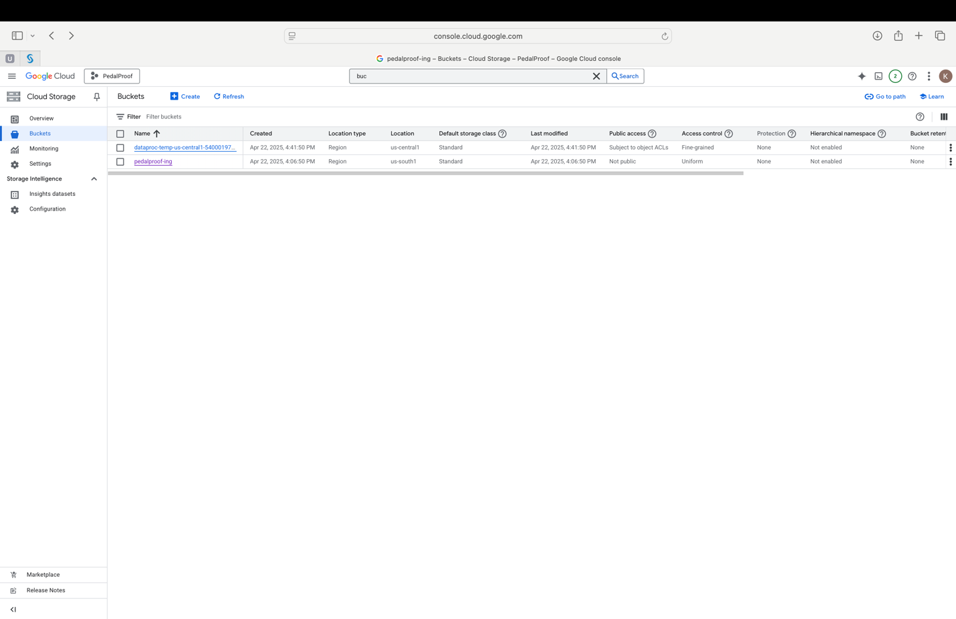

Screenshot Owner: Siva Karthik

Application Used: Google Cloud Platform

Tasks Performed:

* In order to store static datasets, a Cloud Storage bucket was created in GCP.
* The static dataset about bicycle accidents was uploaded to the storage bucket.
* To guarantee safe access to the static data for additional processing, set permissions.

Screenshot 5 — Datasets Uploaded (San Diego, Tempe, NYC) – Karthik

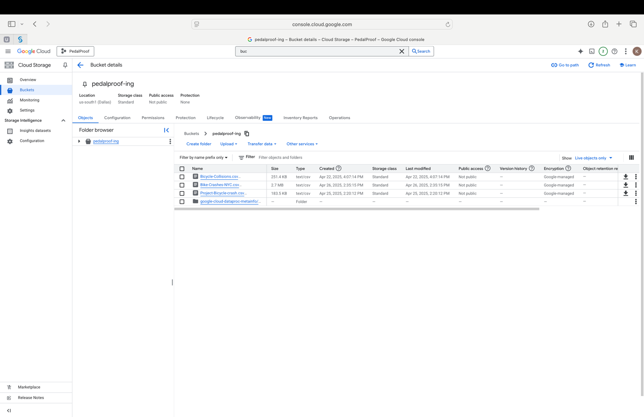

Screenshot Owner: Siva Karthik

Application Used: Google Cloud Platform

Tasks Performed:

* Static datasets about bicycle occurrences from New York City, Tempe, and San Diego were uploaded to the GCP Storage bucket.
* Confirmed that every dataset had been uploaded accurately and was arranged in the bucket folders.
* Prepared the datasets for use with GCP services for additional processing and querying.

## Phase 2: OpenRefine

Dataset 1: SD – Teja

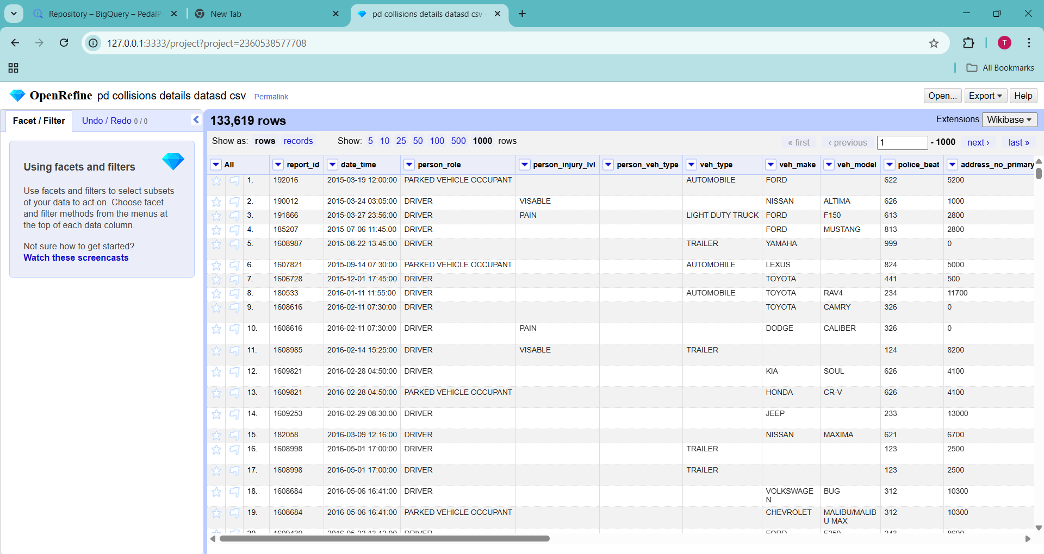Before: -

Screenshot Owner: Teja Sai Srinivas Kunisetty

Application used: OpenRefine

Tasks Performed:

* Loaded the static dataset based on the city of San Diego into OpenRefine.
* Cleaned the dataset by only including the relevant columns.
* Filtered the dataset to know only about bicyclists

In the updated version of the dataset, a data cleaning step was performed to correct misspellings in the person_injury_lvl column, i.e., the incorrect value "VISABLE" was corrected to the proper spelling "VISIBLE" across all relevant rows.

By doing the above steps, it helps to understand the information clearly, as the dataset now only contains the data that we wanted to work with in the correct data types.

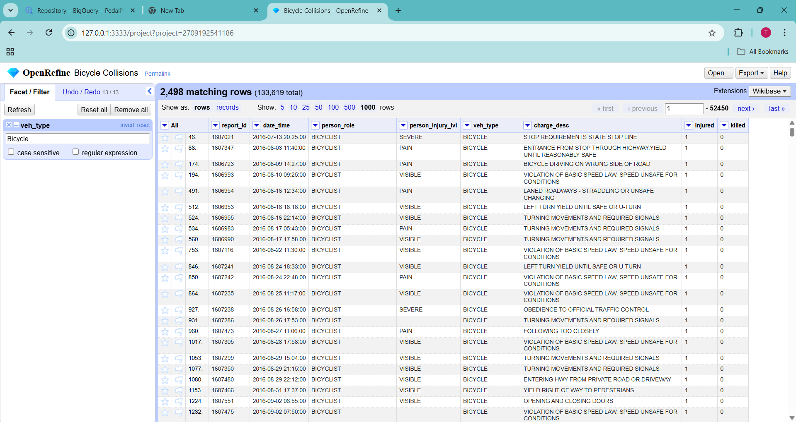After:

Screenshot Owner: Teja Sai Srinivas Kunisetty

Dataset 2: Tempe – Divya

Screenshot 6 – Before

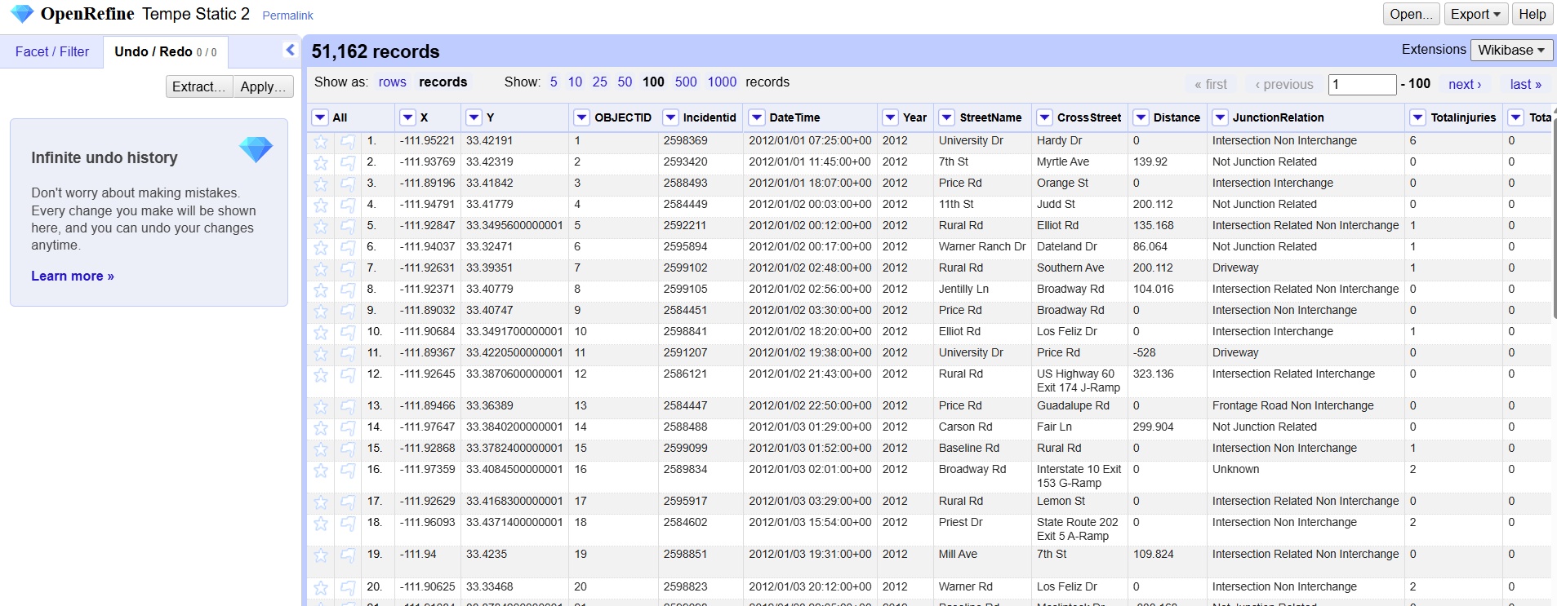

Screenshot Owner: Pithani Divyasree

Application used: OpenRefine

Tasks Performed:

* Loaded the static dataset into OpenRefine. Cleaned the dataset by only including the relevant columns.
* Filtered the dataset to know only about pedal cyclists.
* Transformed the total_injuries and total_fatalities values from text to numeric.
* Transformed the age from text to number and edited the outliers.

By doing the above steps, it helps to understand the information clearly as the dataset now only contains the data that we wanted to work with.

Screenshot 7 – After

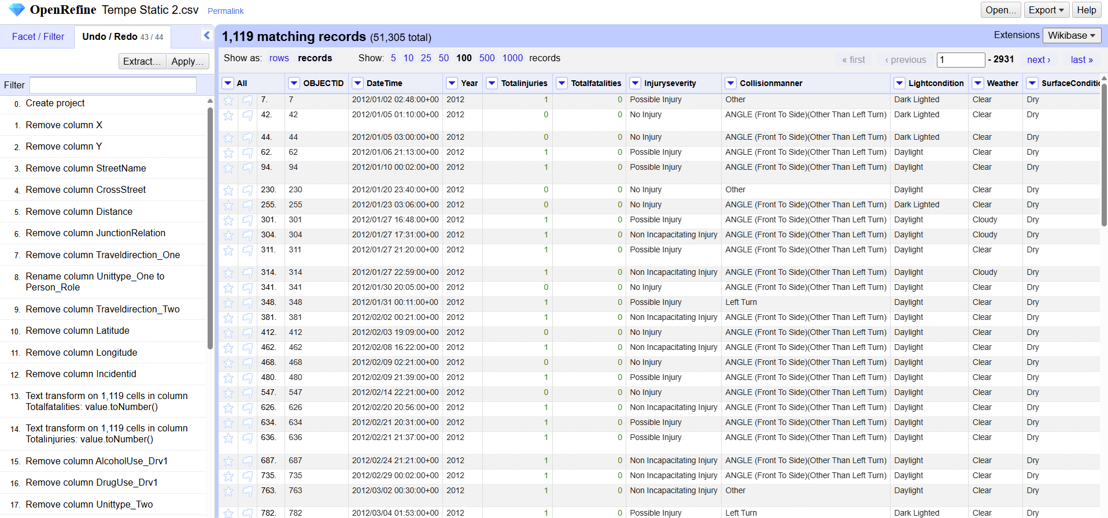

Pithani Divyasree

The above screenshot displays the data after the required cleaning is done.

Dataset 3: NYC - Divya

Screenshot 8 – Before

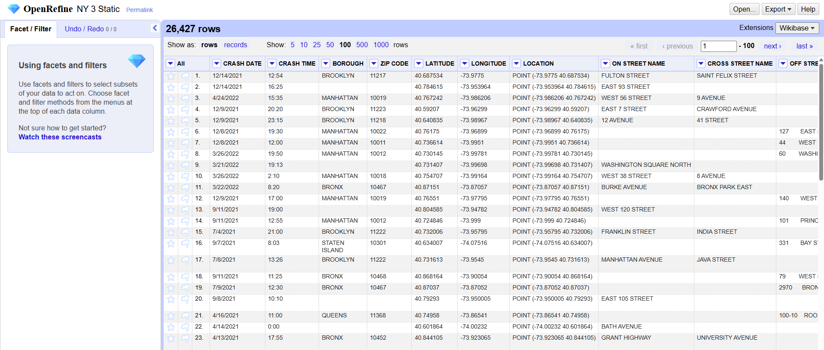

Screenshot_Owner: Divyasree Pithani

Application Used: OpenRefine

Tasks performed:

* Data loaded, and project created on OpenRefine.
* Changed the Number of persons injured from text to numeric.
* Edited the blank rows in vehicle type code 2 to unknown
* Transformed the three columns Number of persons Injured, Cyclist Injured and Cyclist killed from Text to Numeric.

All the above cleaning helps in making the data precise for using it in the next steps of the data life cycle.

Screenshot 9 – After

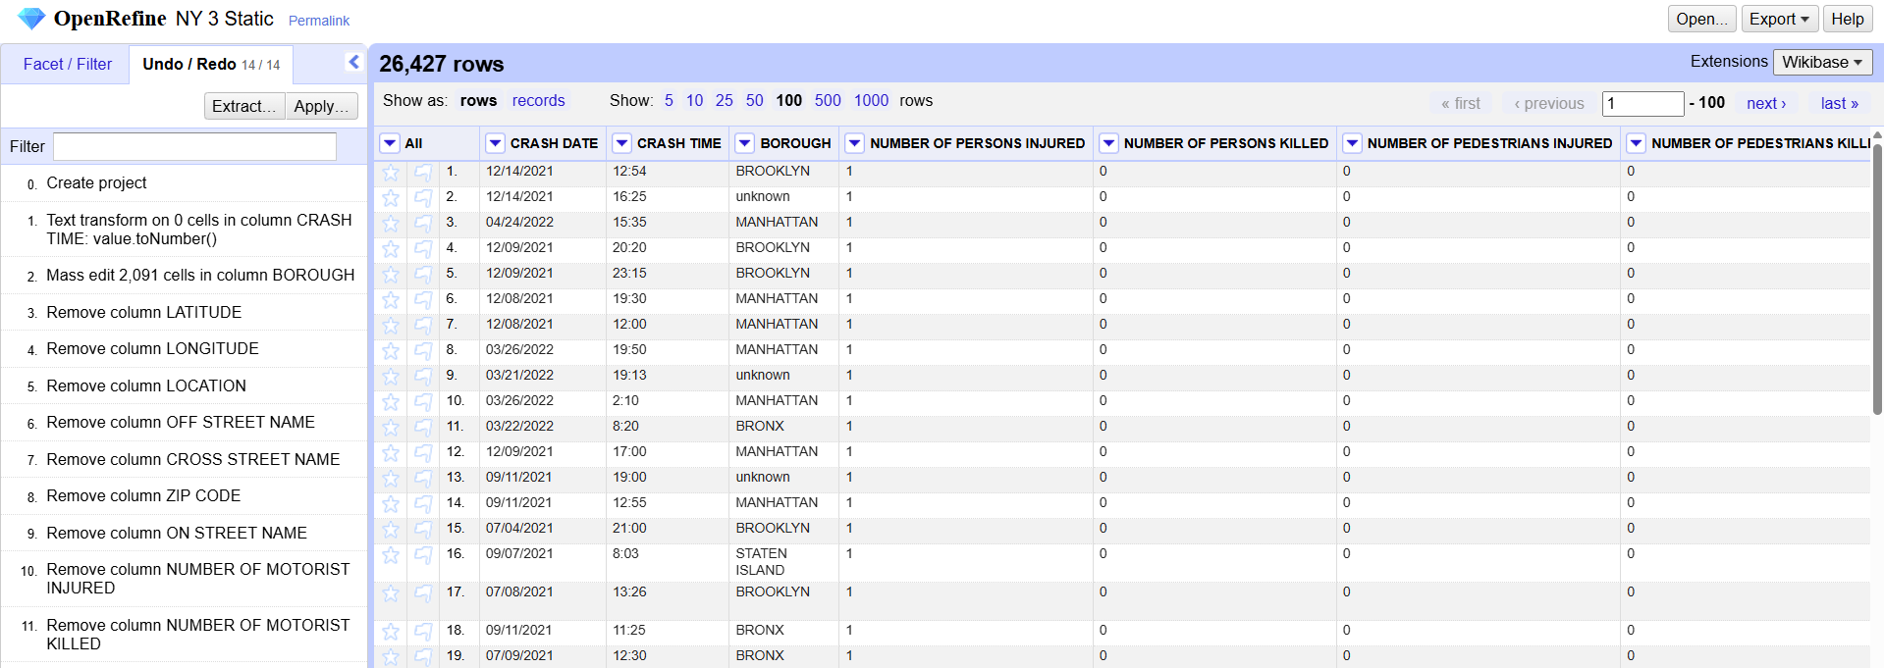

Screeenshot_Owner : Divyasree Pithani

This is the screenshot of OpenRefine after the required cleaning is done.

## Phase 3: Hive Table Creation

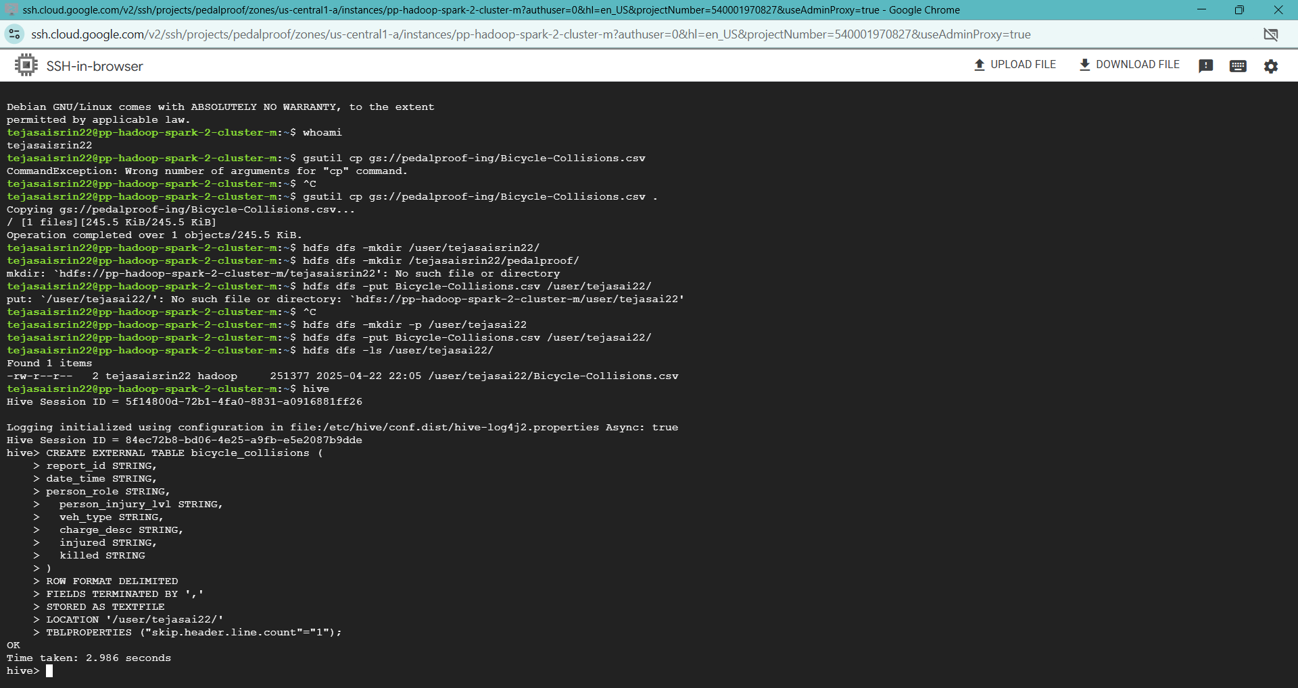Screenshot 6 — Hive External Table for San Diego (Teja)

Owner: Teja Sai Srinivas Kunisetty

Screenshot 7 — Hive External Table for Tempe.

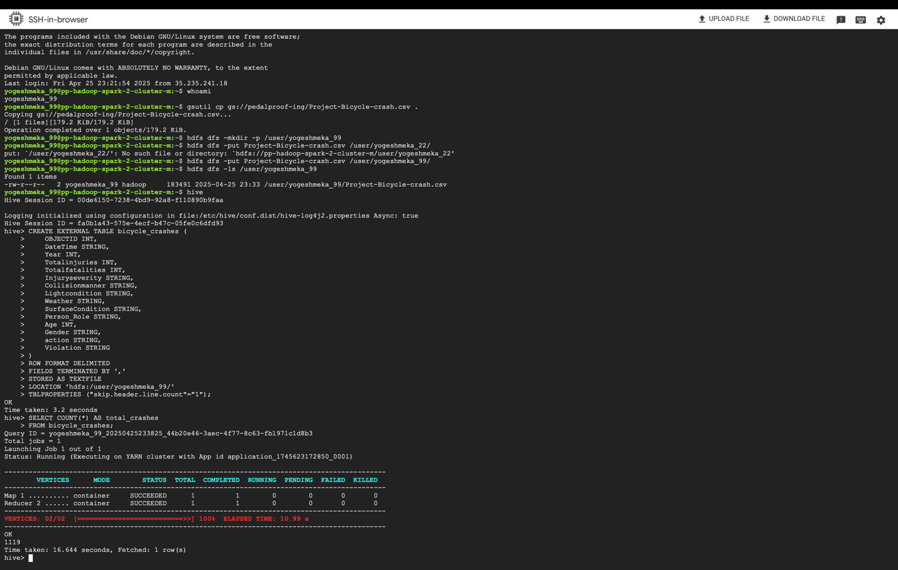

Owner: Yogesh Meka

We managed to create an external Hive table bicycle_crashes with some fields like date/time, year, injuries, age, gender, etc., from a CSV in HDFS, and then executed a SELECT COUNT (*) to check total crash records and it returned 1119.

Screenshot 8:

Injury crashes (TotalInjuries > 0): Result was 982. Fatality crashes (TotalFatalities > 0): Result was 98. Crashes by year, showing a trend over 2012–2024. The peak year was 2012 (160 crashes), and there was a sharp decline in 2020 (38 crashes), possibly due to pandemic issues.

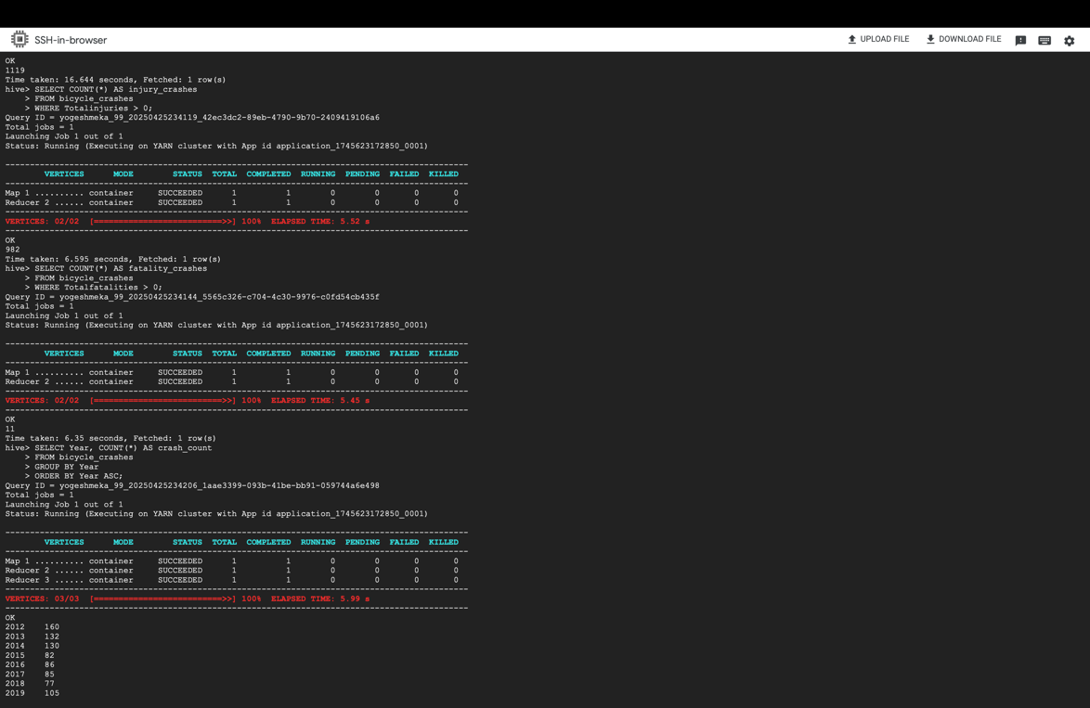

Owner: Yogesh Meka

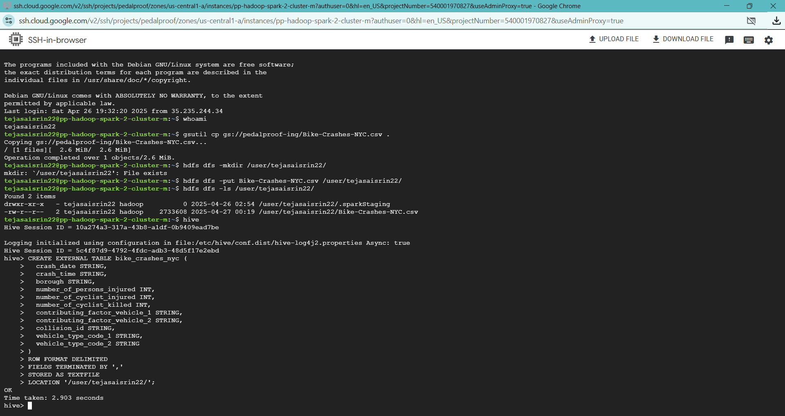Screenshot 9 — Hive External Table for New York (Teja)

Owner: Teja Sai Srinivas Kunisetty

## Phase 4: SparkSQL Queries

1. San Diego Dataset: - Teja

Screenshot 10 — SparkSQL Query on San Diego (basic crash counts) – Teja

1. Launching pyspark Loading the dataset:

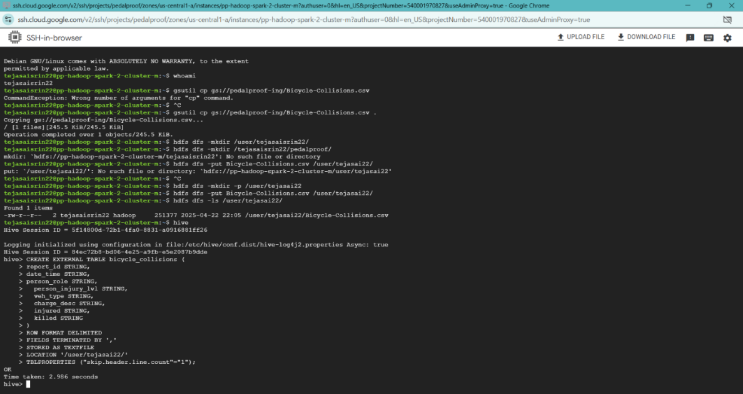

1. Basic Data Exploration:

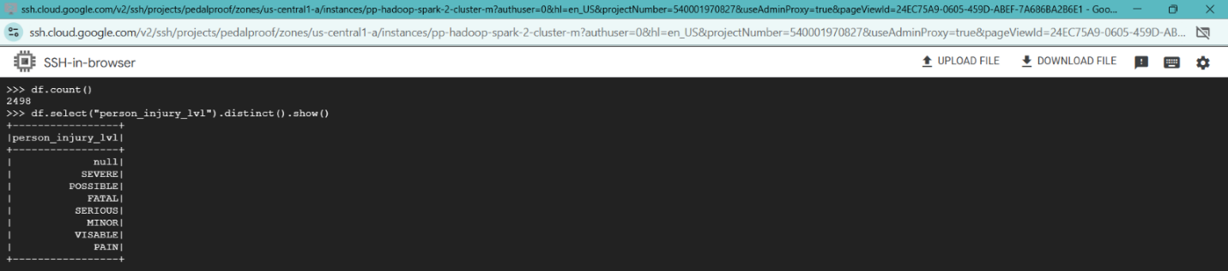

1. Severity Profile of Bicycle Incidents - Understand what proportion of incidents result in injuries of various severity levels.

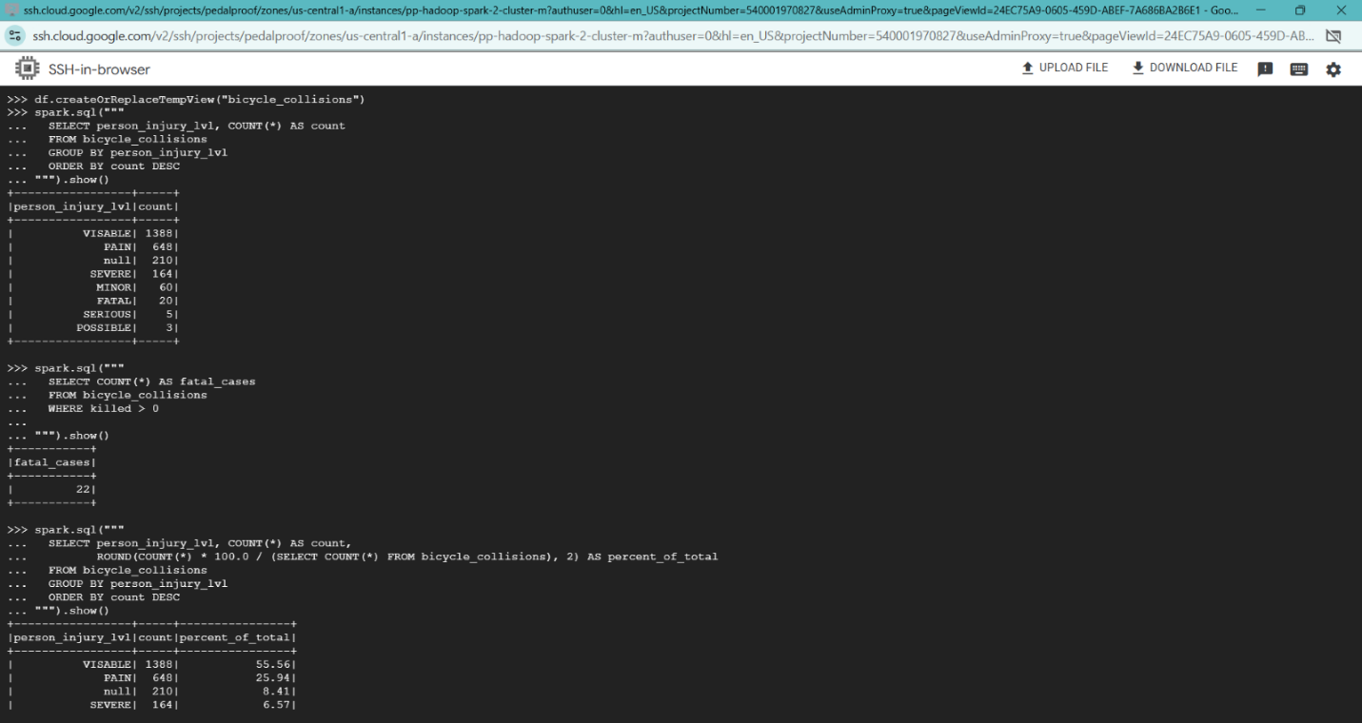

1. High Fatality Incident Types (veh_type) - Identify the vehicle types most associated with cyclist fatalities.

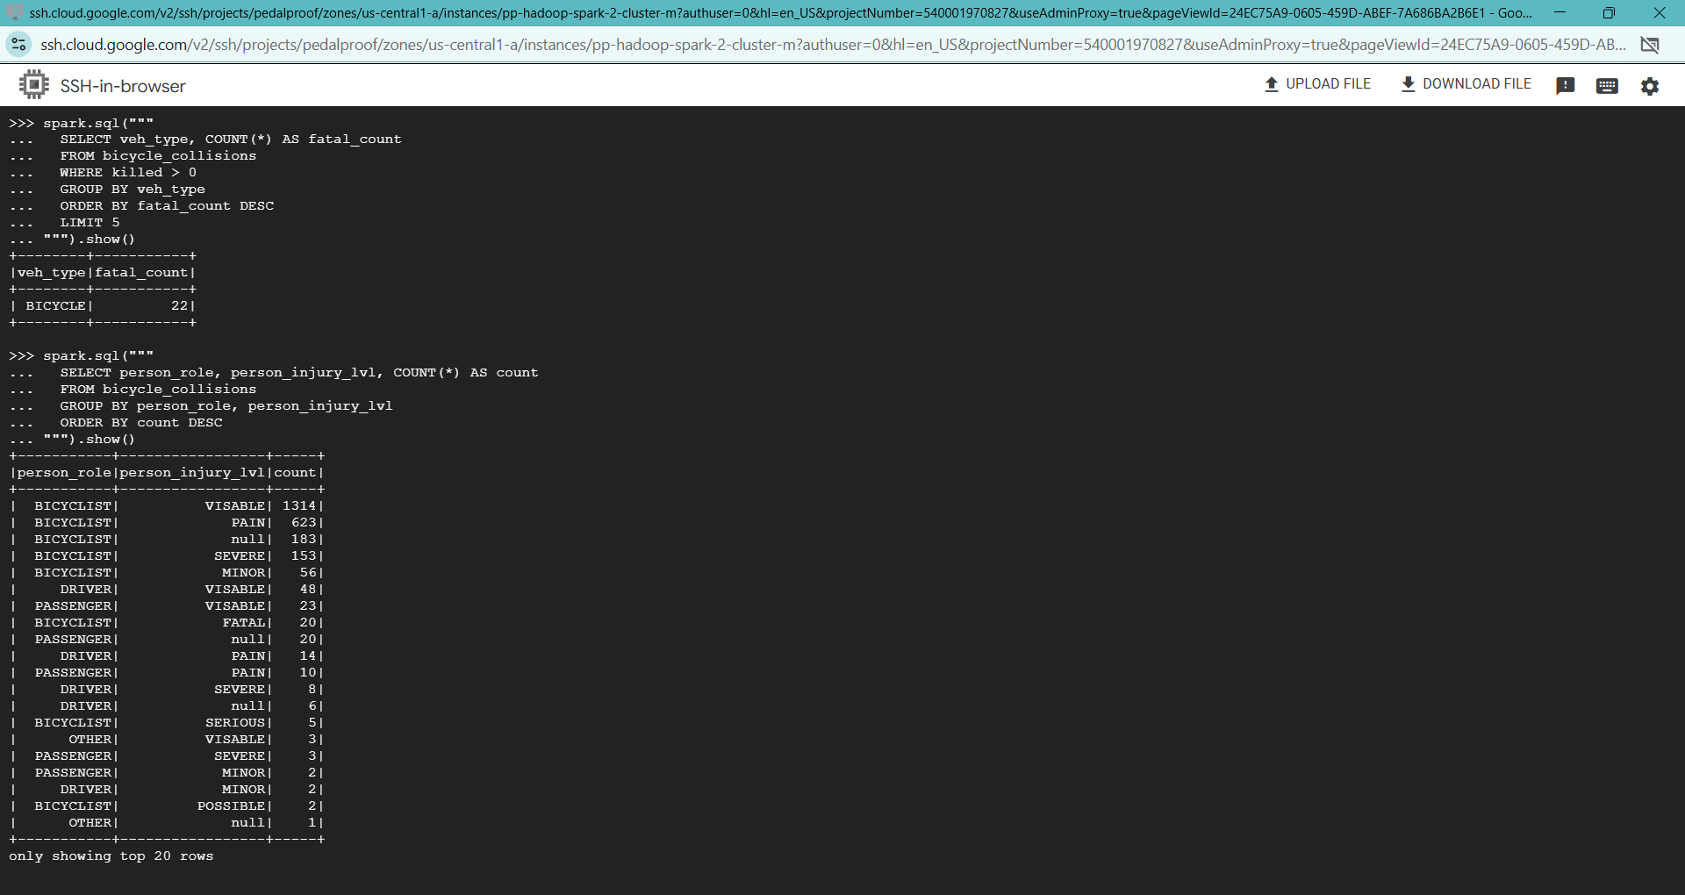

1. Injury Level by Cyclist Role - Reveal whether the cyclist was a driver, passenger, pedestrian, etc., and their injury outcome.
2. Potential Violation Descriptions Leading to Injuries - Spot trends in traffic charges or behaviors that frequently result in cyclist injuries.

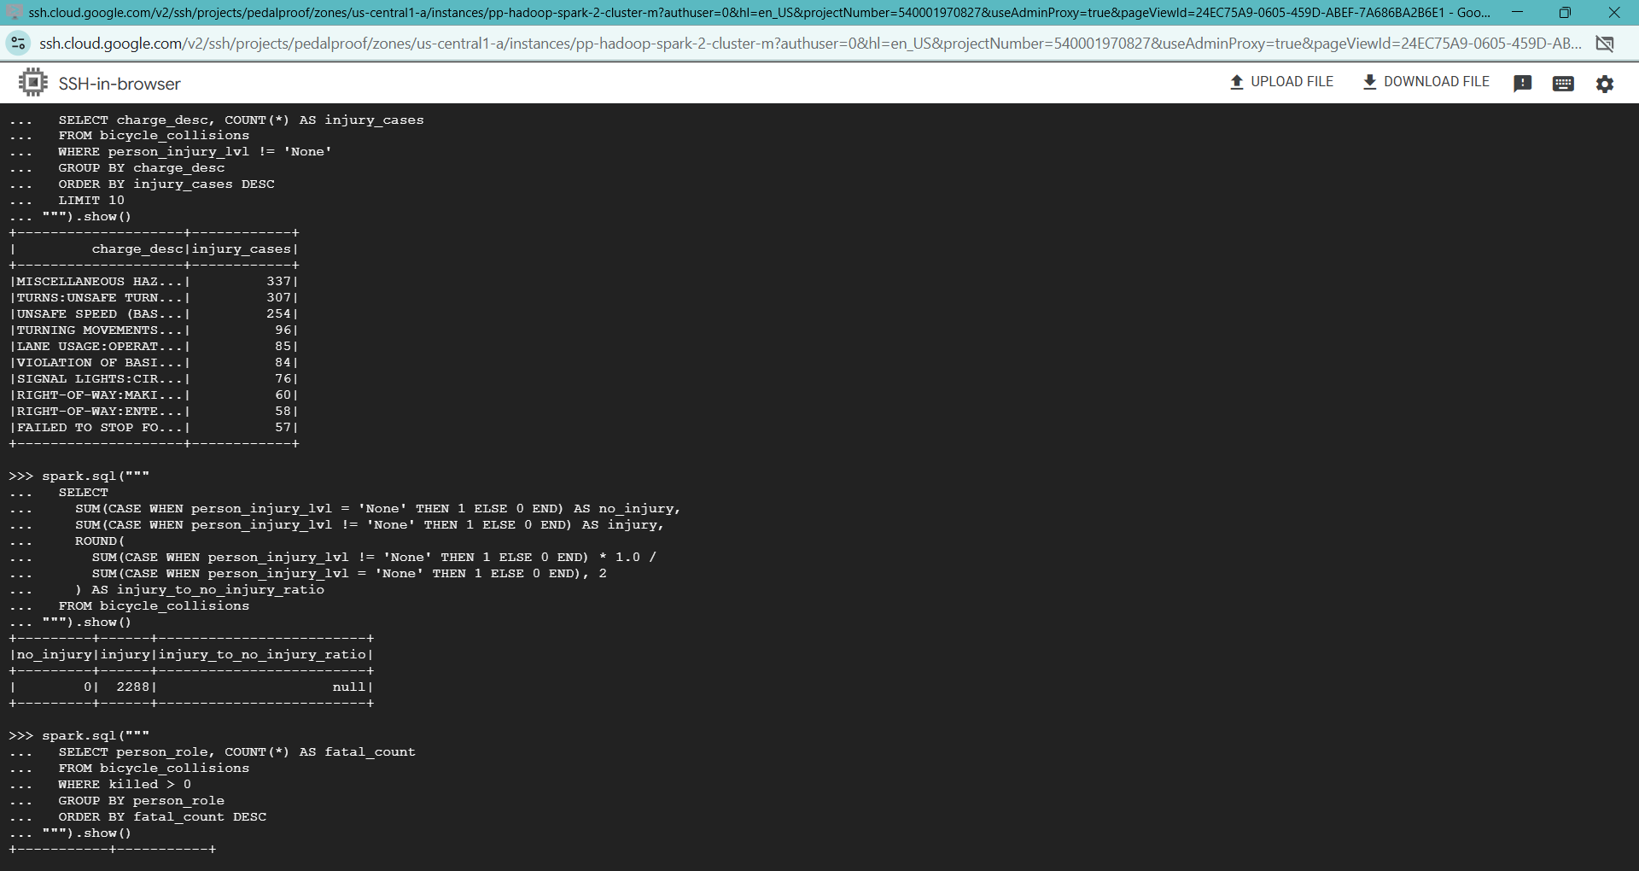

Screenshots of the Queries run by Teja Sai Srinivas Kunisetty

1. City of Tempe –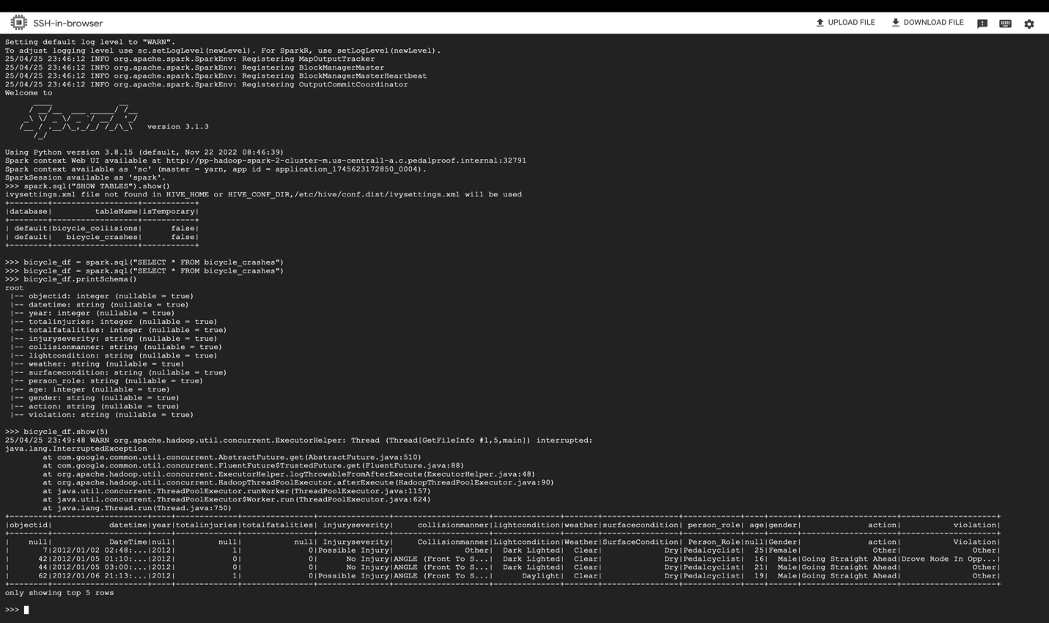

Screenshot 11 A Owner: Yogesh

Initialized PySpark session and linked with Hive successfully.

1. After having queried the bicycle_crashes table using Spark SQL, it displayed the schema (with data types) and previewed the top 5 records, including fields like CollisionManner, Weather, Person_Role, etc.

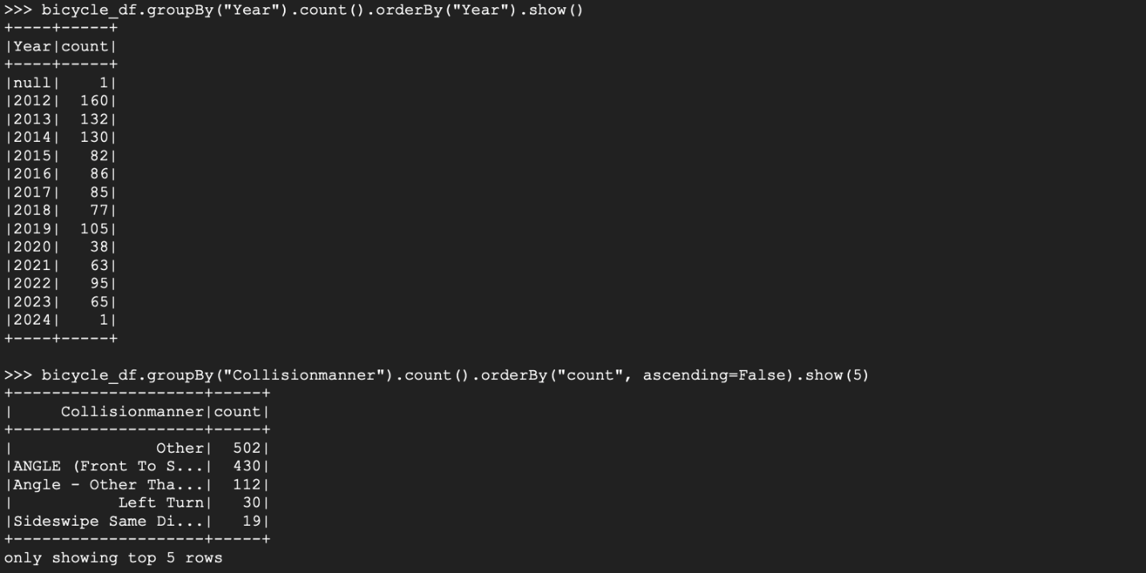

Screenshot 11 **B** Owner: Yogesh

B. Two queries were executed:

* Divided records by Year to find out how many crashes occurred each year. This was equivalent to your Hive query output.
* Then sorted by CollisionManner to find top 5 types of crashes. Most common was "Other" (502 cases), and second was "ANGLE (Front to Side)" (430 cases).

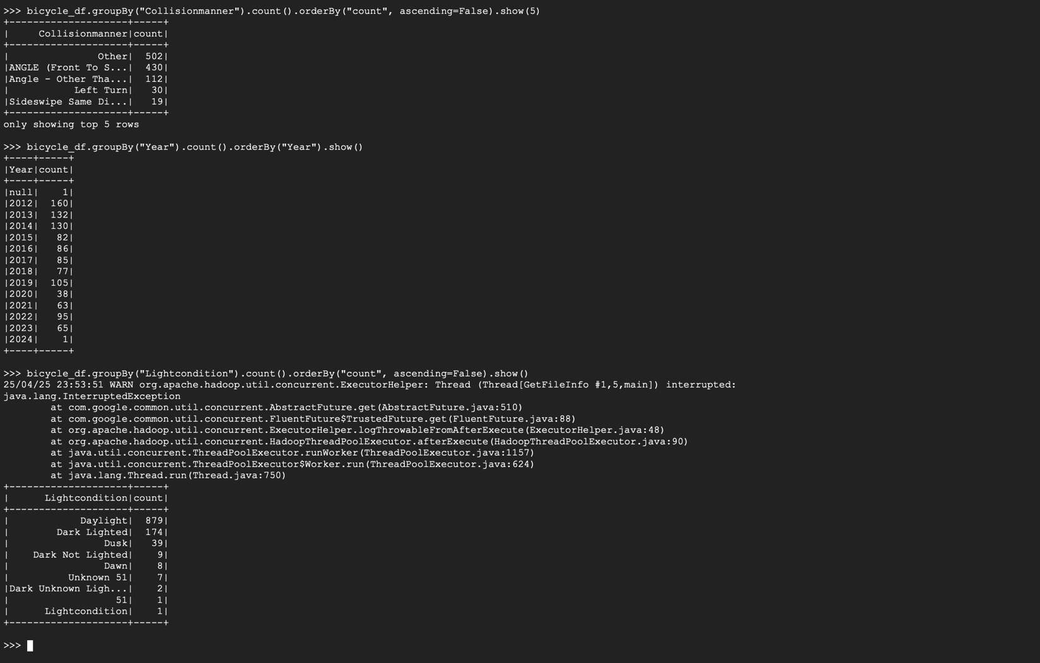

Screenshot 11 C Owner: Yogesh

C. compared the frequency of crash by Light Condition, with the majority happening in Daylight (879) followed by Dark Lighted (174). Following a minor executor warning, the outcome was correctly presented, showing that lighting conditions are a significant factor in crash trends.

1. SparkSQL Queries on New York (borough-based crash analysis) – Teja
2. Total Number of Bike Crashes; Crashes by Borough (Top Areas)

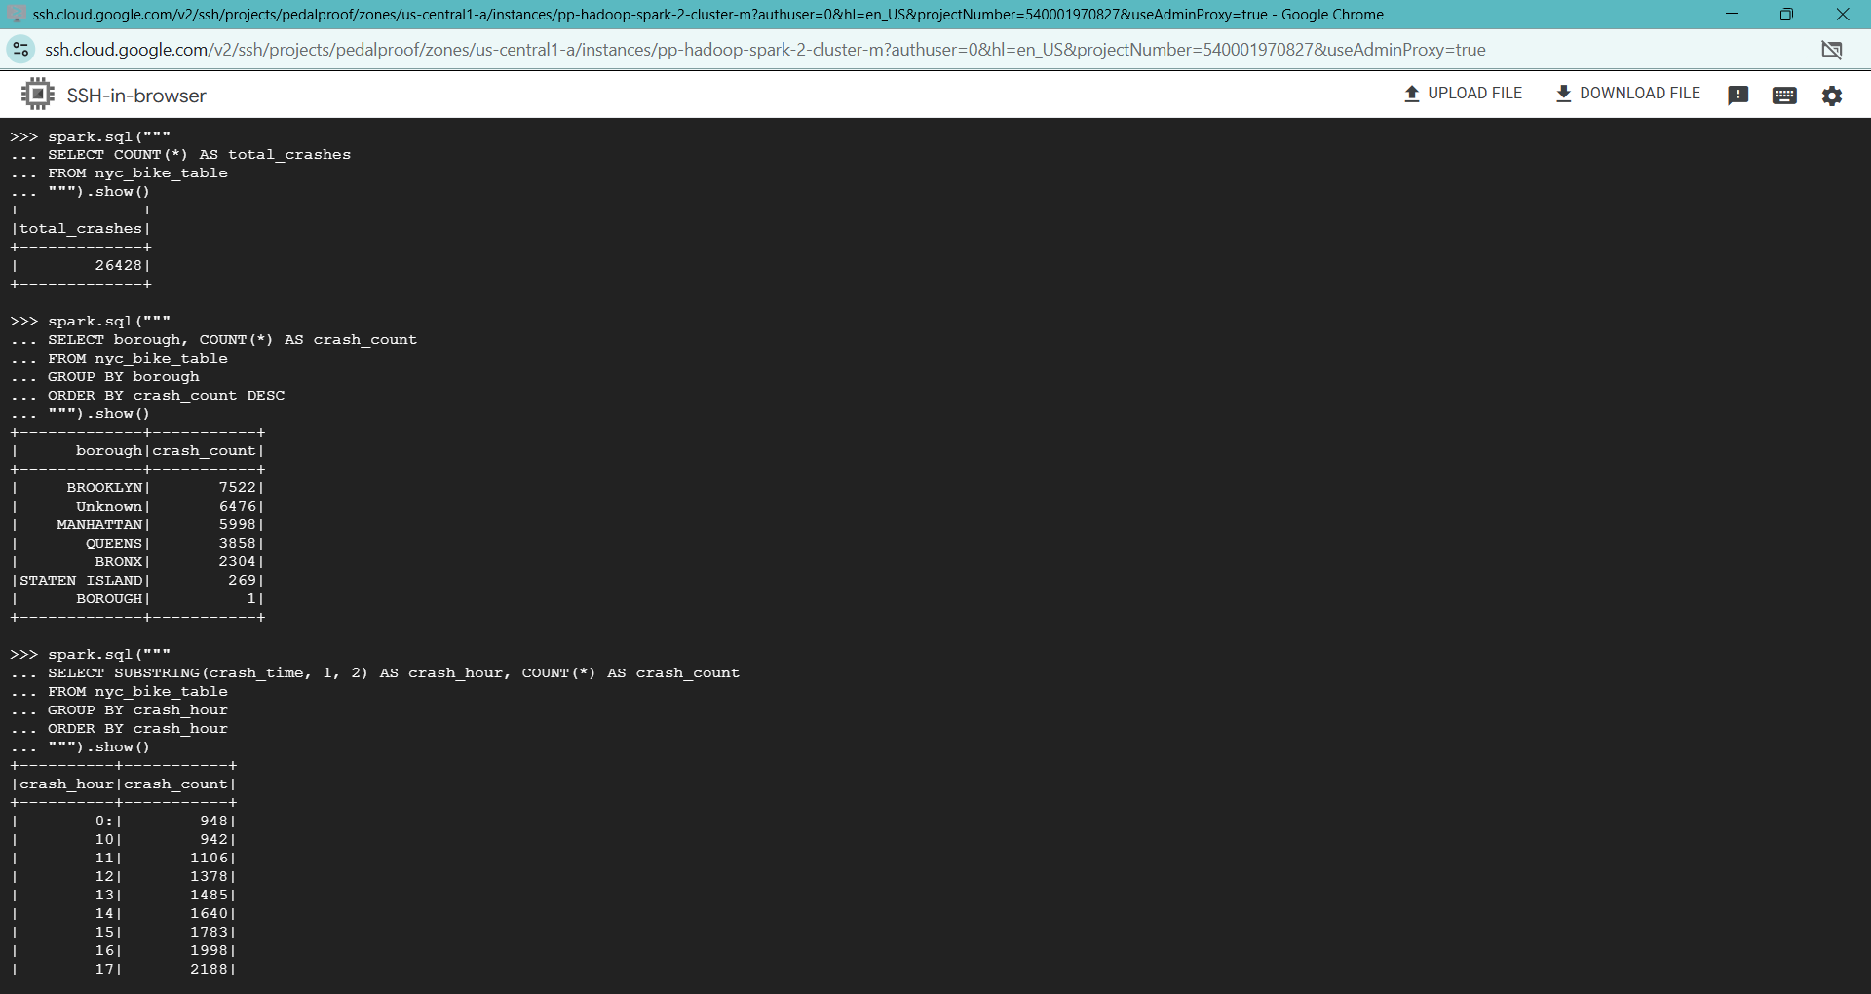

A total of 26428 bike crashes were recorded in New York City over the analyzed period.

Brooklyn and Manhattan reported the highest number of cyclist crashes among all boroughs, while a significant portion of incidents with unspecified borough information were recorded under 'Unknown'.

1. 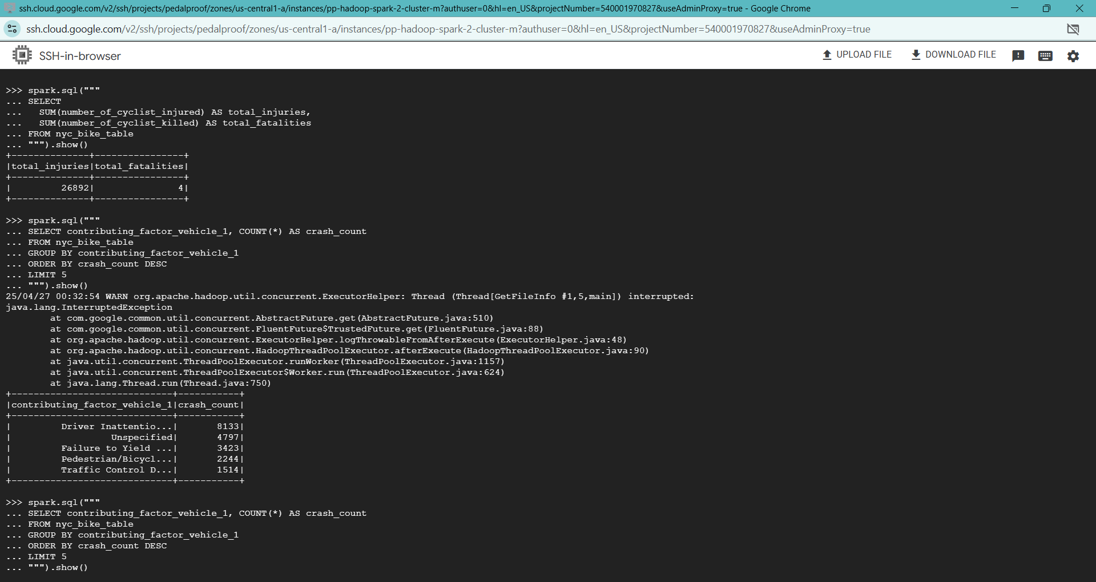Total Cyclist Injuries and Fatalities; Top 5 Contributing Factors (Crash Causes)

There were around 4cyclist deaths during the study period, highlighting severe road risks for cyclists.



Driver inattention/distraction and failure to yield were the leading causes of cyclist crashes.

1. Vehicle Types Involved in Bike Crashes (1 and 2)

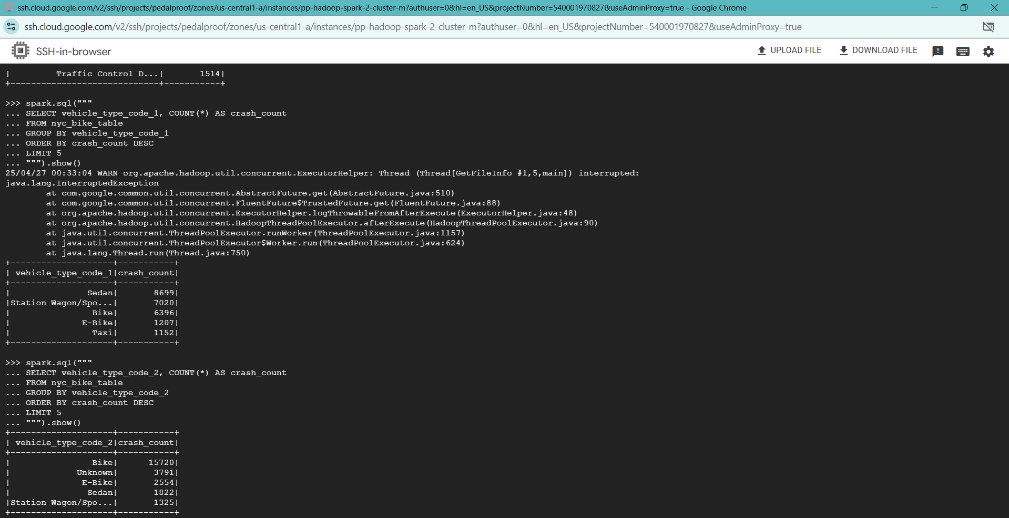

Sedans and Bikes were the top involved vehicles in the accidents.

1. Deadliest Contributing Factor for Cyclists

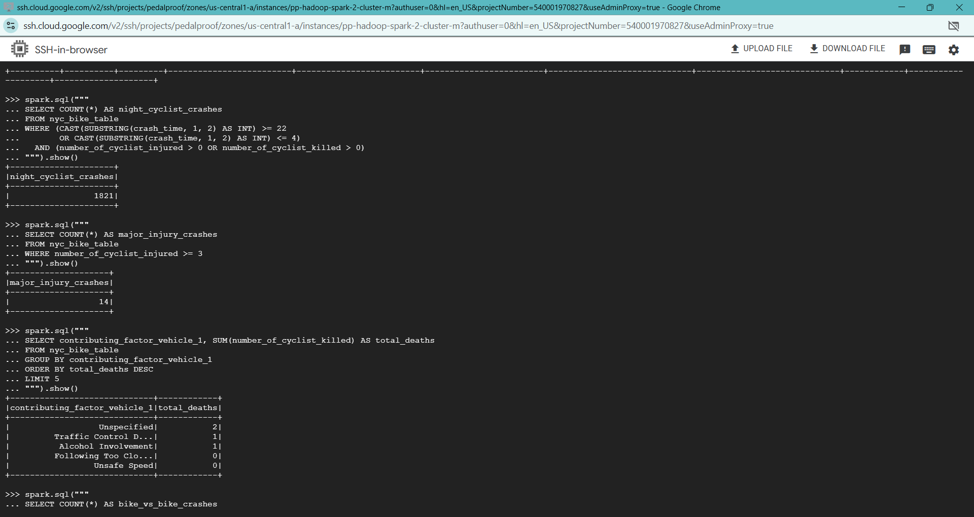

1. Crashes where both Vehicle 1 and Vehicle 2 are Bikes (rare but interesting)

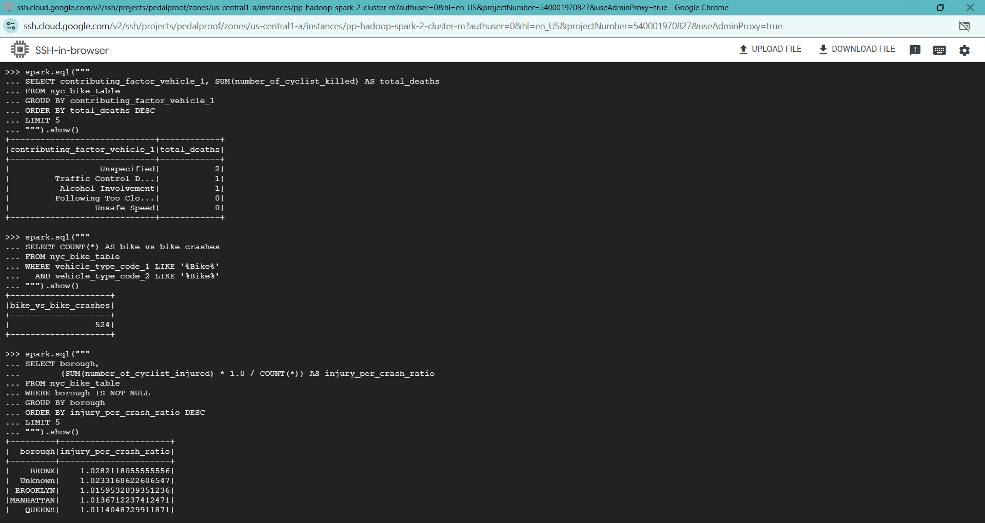

Bike vs bike collisions were rare, with only few recorded incidents.

1. Daytime vs Nighttime Crash Split (Full Comparison)

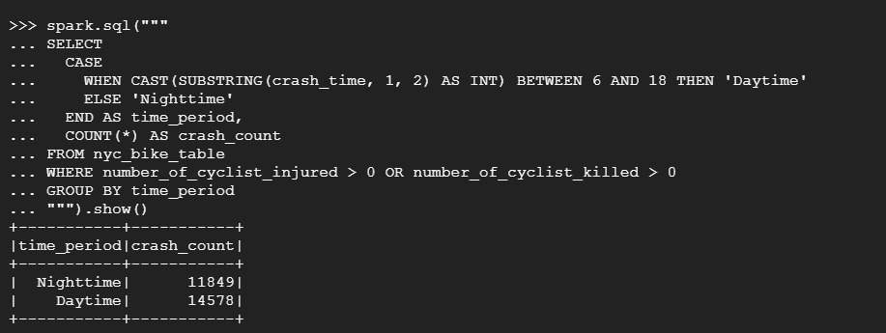

The majority of cyclist crashes occurred during daytime hours, with approximately 11849 crashes during daytime and 14578 crashes during nighttime, indicating higher traffic exposure during the day

Screenshots of the Queries’ Execution by Teja Sai Srinivas Kunisetty

## Phase 5: BigQuery Advanced Analysis BigQuery Project and Datasets Setup, Tables Loading – Bhargav

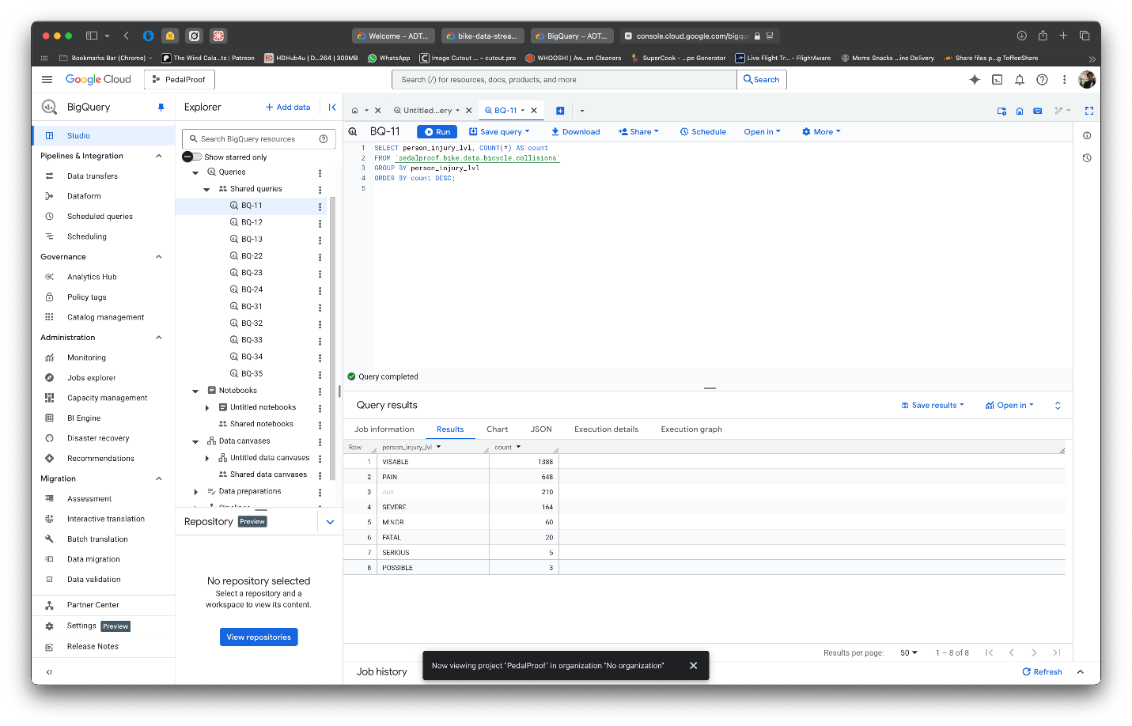

* Counts Lesions per Type of Violence (e.g., Visible, Pain, Severe).
* “VISIBLE” Injuries - most widespread, 1388 cases.
* Helps shrinks comprehend severity engendering spread of accidents.

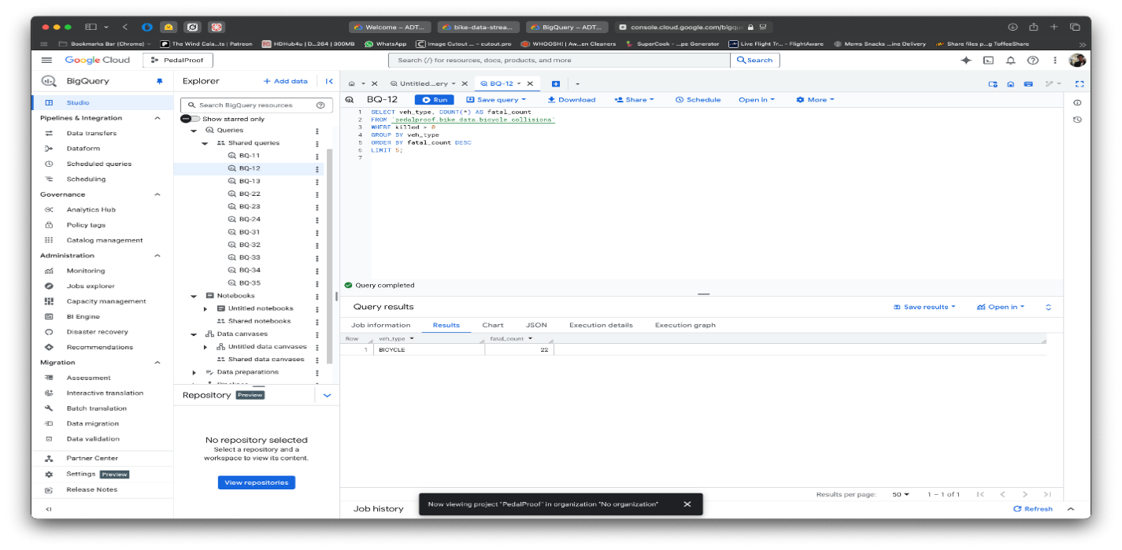

* Finds whodunit vehicle Detail in acute crashes were killed = 1.
* Only BICYCLE bushed listed with 22 saboteurs.
* It is aimed solely at events of deadly violence.

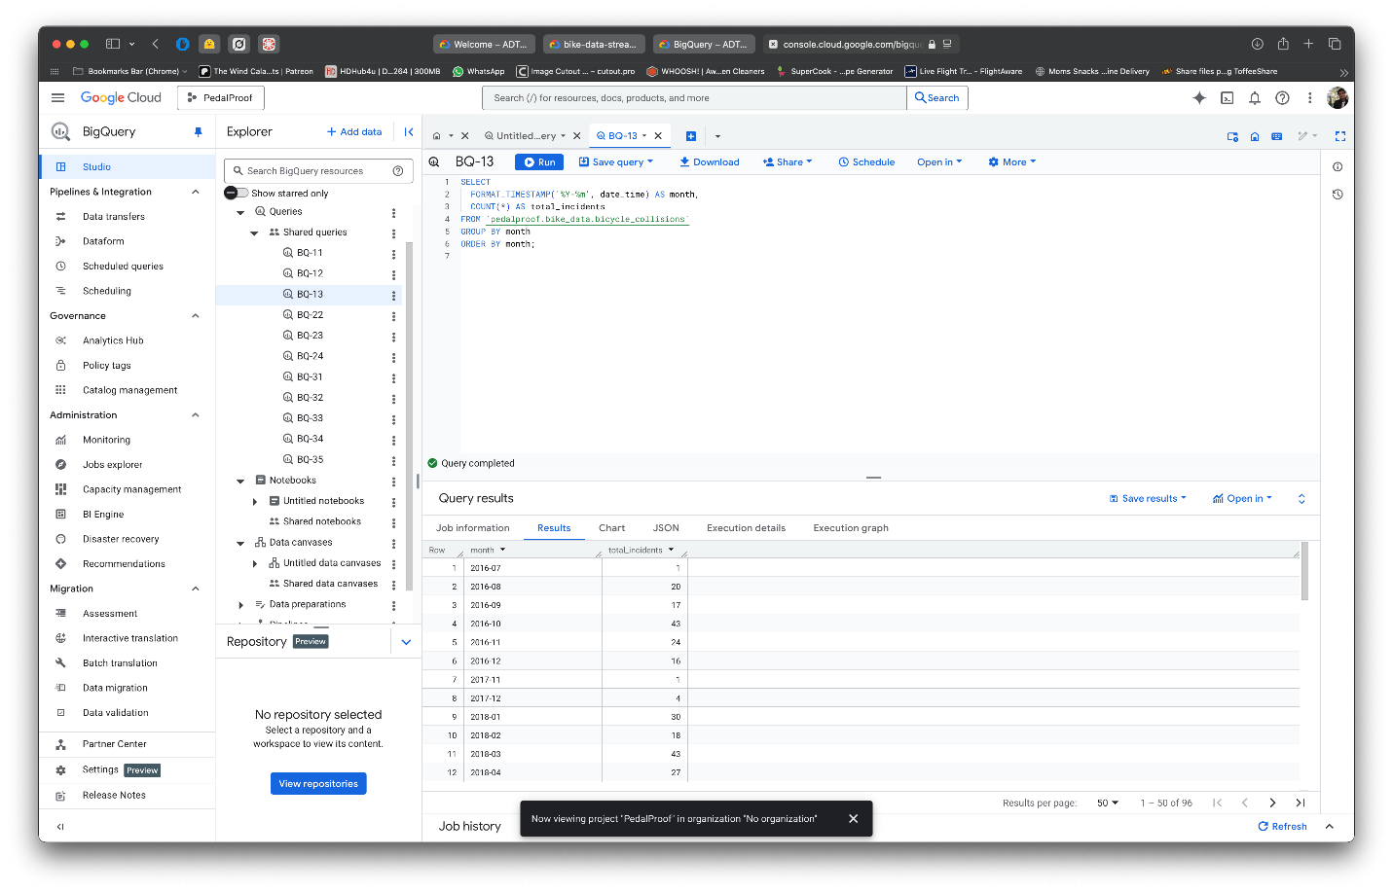

* Aggregates column a depository of all them bicycle collision incidents by month using timestamp template.
* Shows how sinks shifting across months (eg. uptick in November2016).
* Good for checking on seasonal rhythms.

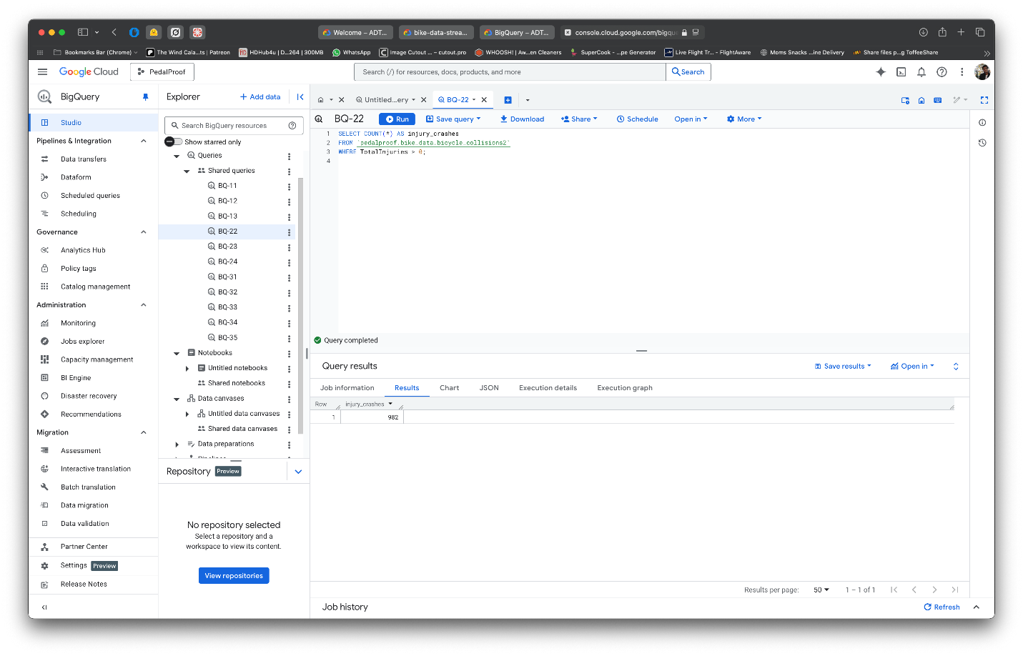

* Counts summation of all sore spots of action which came through injury (TotalInjuries > 0).
* Determines that 982 injury-bounds crashes are kept in a fragmented record.
* Good for estimating the amount of cases in injuries incidents.

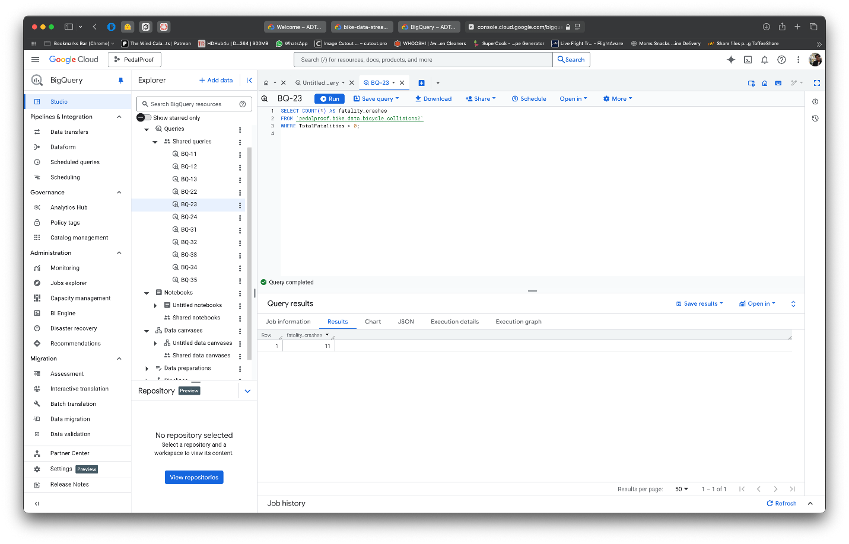

* Counts total number of collapsing spending accounts that resulted in death (TotalFatalities > 0 completed).
* Observes total sum of crushing stoppages tenders 11 suffocating.
* Absence of death reduces excessive kills worthless view risk level violence.

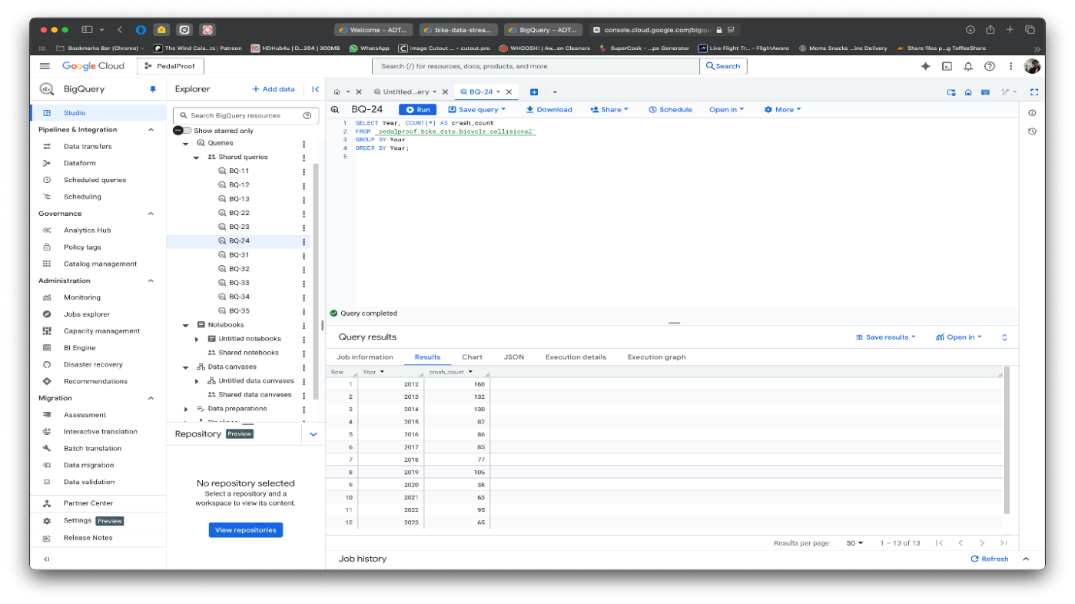

* Count total num of speeches per chronic.
* Notes that speeches peak ended picture 12th year of current millennial and sinks to 160 and later reduced till 2023.
* Reverses yearly wheels forth limited view motorcycle crashes on emptied roads.

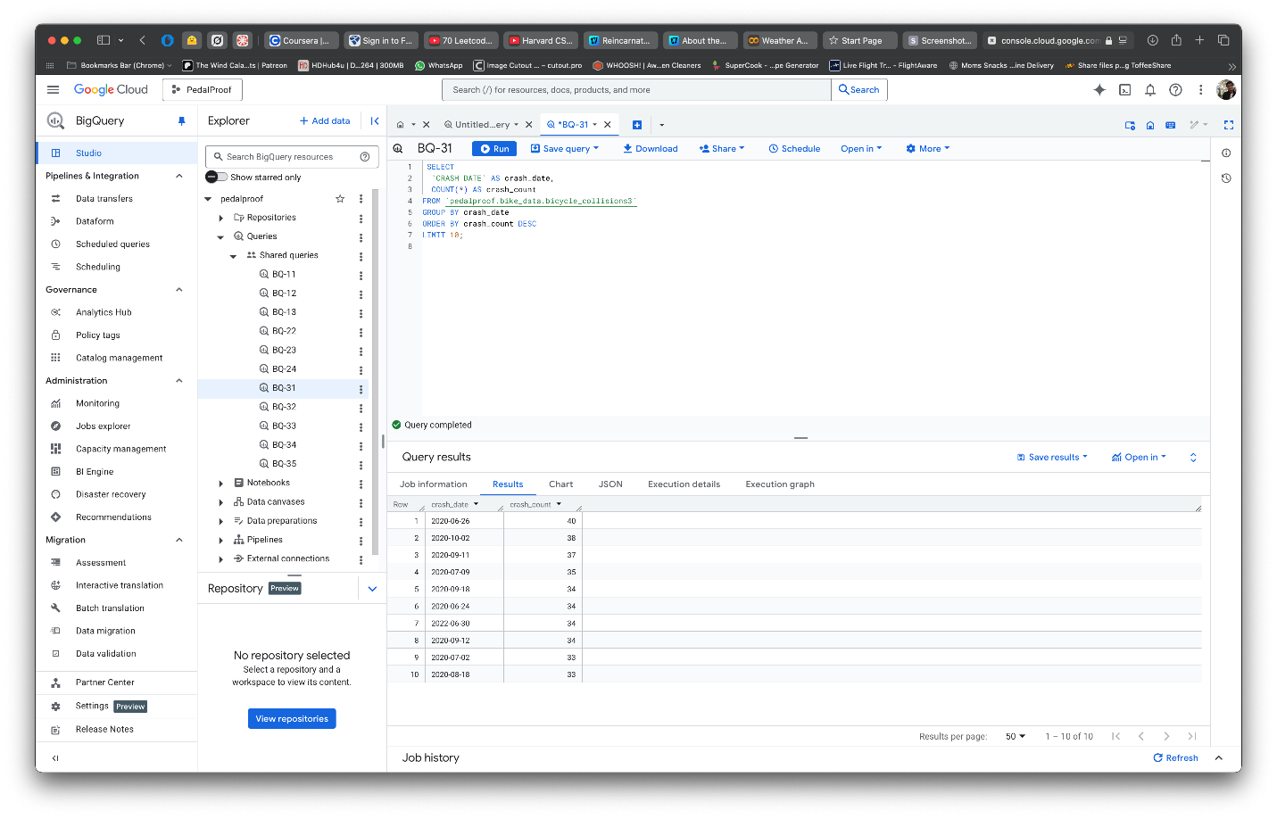

* Creates account of the highest number of speeches in ten days.
* Cited date 26-06-20,29 crashing on single day capped.
* Discovers day with heavy shattered for these crashes.

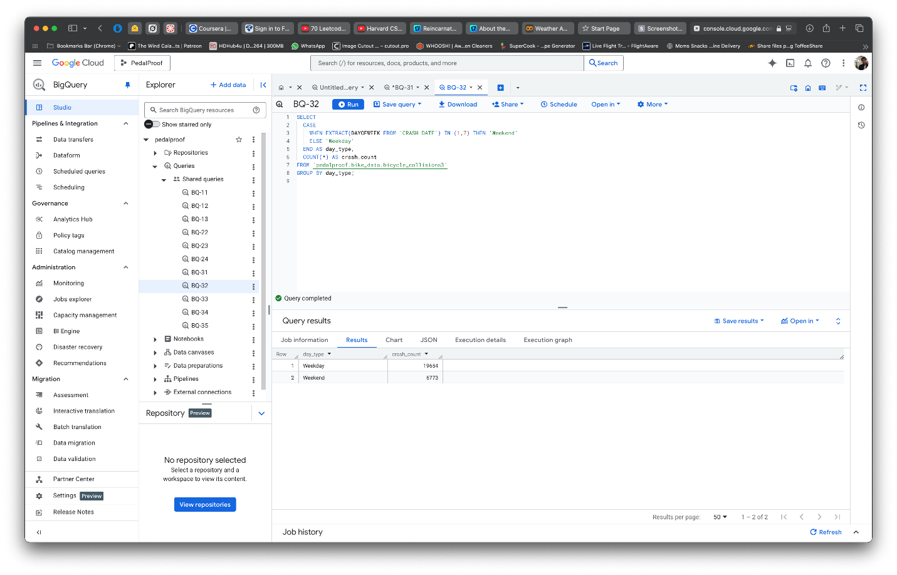

* Classifies accidents into “Weekday” and “Weekend” categories as per the date of the accident.
* Discovers weekdays have more crashes 19,654 than weekends 6,773.
* Aids in grasping the time aspect of crashes.
* Calculates the mean value of crashes per borough (area).
* Leads to Brooklyn being the highest with about 4.12 crashes per day.
* Helps in understanding the geography of the crashes.

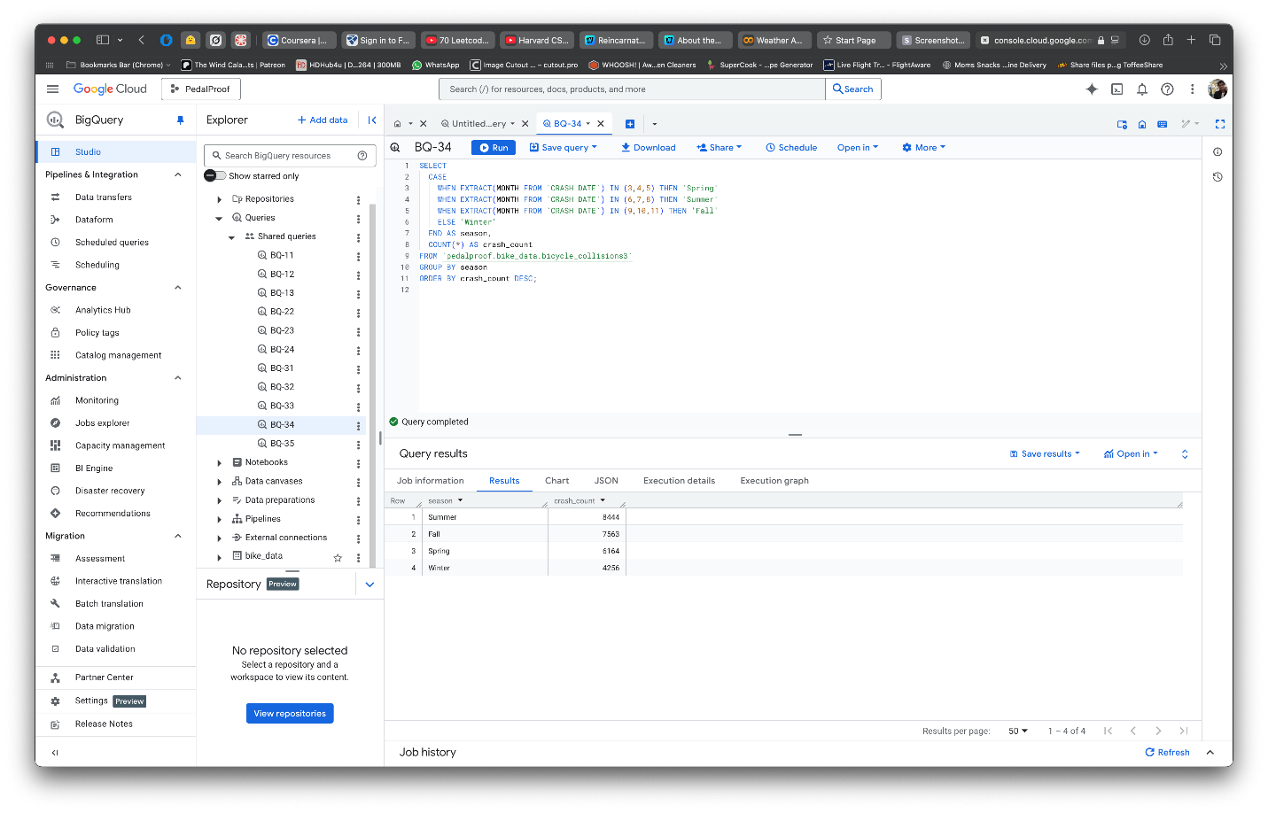

* Uses the month of the accident to group the crashes by season (Spring, Summer, Fall, Winter).
* Holds Summer with the highest number of crashes (8,444 incidents).
* Highlights the change in crash frequency as per seasons.

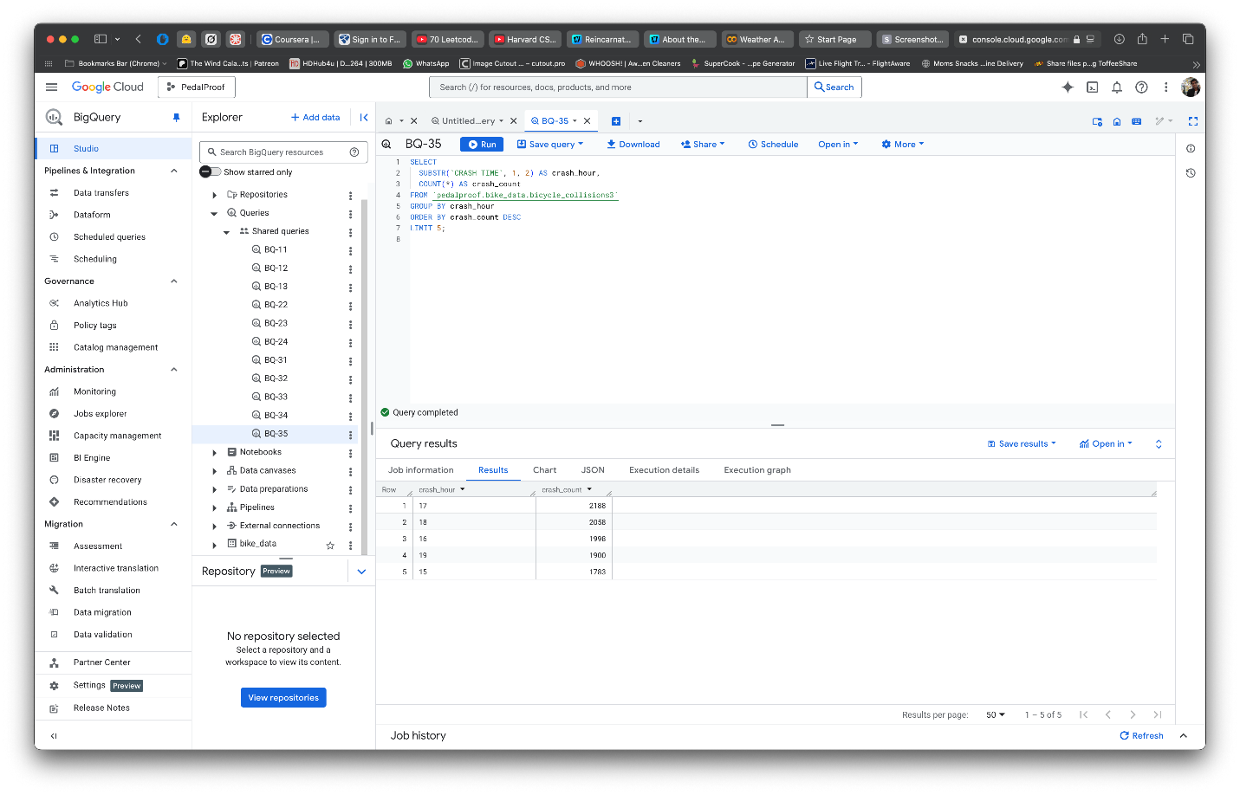

* Organizes the data into hourly increments based on the first two characters of the crash time.
* Demonstrates that most accidents happen between 3 PM and 6 PM.
* Aids in assessing timeframes for accidents in relation to traffic volume for effective traffic control.

# Key Findings

**San Diego:**

* Although particular environmental conditions were not recorded, the majority of crashes were documented during the day in clear weather.
* Most of the cases were cyclists who were hurt because they were breaking the law, such as by speeding, failing to yield, or riding on the wrong side of the road.
* Relatively few fatalities were documented, and the severity was primarily pain or obvious injuries.
* Deeper causal analysis was hampered by the absence of weather, surface, and time-of-day information.
* The most common reasons were infractions like as stop sign violations and dangerous lane changes.

**Tempe:**

* The temperature information was more comprehensive, encompassing rider demographics (gender, age), surface and light conditions, and weather.
* The majority of collisions happened on dry roads throughout the day and in clear weather.
* Most often, younger male bikers between the ages of 16 and 25 were involved.
* During collisions, "going straight ahead" was the most common action.
* Environmental data suggested behavioral issues by showing that even favorable weather and lighting conditions did not completely avoid accidents.

**New York City:**

* Of the three cities, NYC had the most bike crashes overall (around 26,000 incidences).
* Although a lot of incidents were reported with an unidentified municipality, Brooklyn had the most bike crashes.
* Most collisions happened throughout the day, particularly during the 4–7 PM evening rush hour.
* The main causes were the driver's negligence and inability to yield.
* Nighttime crashes had a higher risk of fatalities per crash, even though daytime crashes were more frequent.

# Potential Solutions

# A mix of enforcement, education, and infrastructure measures is needed to increase bike safety in Tempe, New York City, and San Diego. The severity of crashes can be decreased by increasing protected bike lanes and improving street lighting, especially in high-risk regions. Both public awareness efforts encouraging safe road-sharing and stricter enforcement of traffic infractions including failing to yield and inattentive driving are crucial. Nighttime crash hazards can be reduced by encouraging the use of visibility equipment, such as bike lights and luminous clothing. In order to facilitate greater analysis and focused safety actions, cities should also improve the collection of crash data, capturing behavioral and environmental elements. Reducing bike injuries and fatalities requires a comprehensive strategy that incorporates data-driven policy, behavior modification, and infrastructure improvements.

# Conclusions

Despite variations in city layouts, traffic congestion, and infrastructural accessibility, the comparative study of San Diego, Tempe, and New York City reveals the pervasive dangers that urban cyclists must contend with. In all three cities, the most common behavioral reasons contributing to bicycle collisions were motorist distraction, inattention, and failure to yield. Environmental factors like daylight and clear weather were present for the majority of crashes, but they did not significantly lower the number of cycling accidents, suggesting that human conduct is more important than environmental factors. Younger cyclists, especially men, were regularly found to be the most vulnerable group in collisions, a trend that was particularly noticeable in Tempe and New York City.

Due to its more comprehensive dataset, Tempe provided deeper insights into environmental effects, but New York City stood out for the sheer number of crashes, which was a reflection of its high bicycle utilization rates and urban congestion. Despite having fewer features, San Diego's dataset reaffirmed how crucial it is to address biker behavior and traffic infractions in order to lower crash rates. Even though riding at night was linked to fewer collisions overall, there was a higher chance of fatalities, highlighting the urgent need for better lighting infrastructure, increased bicycle visibility, and nighttime awareness initiatives.

The results ultimately highlight the need for a mix of more dedicated riding infrastructure, enhanced traffic law enforcement, focused public education on cyclist awareness, and better data gathering procedures to capture more context around occurrences in order to improve rider safety. Significantly lowering bike injuries and fatalities in various urban settings will require a comprehensive approach that addresses behavioral and environmental issues.

**Group 8 Project Meeting Notes**

Note-taker: Divyasree Pithani

Date: (4/22/2025)

Start Time: 2:00 PM

End Time:   3:00 PM

Attendees: Teja and Yogesh (In-Person)

Notes:

* Decided on the first static dataset
* Started working on it

Date: (4/24/2025)

Start Time: 3:00 PM

End Time:   4:00 PM

Attendees: Bhargav, Divyasree, Karthik Raju, Pranavi and Teja. (Online)

Notes:

* To check if the chosen streaming dataset can be used in the project
* Cleaning the static data (ensure to take screenshots)
* To start the final document preparation.
* To finish the project 70% by Sunday.

Date: (4/25/2025)

Start Time: 8:30 PM

End Time:   9:00 PM

Attendees:    Divyasree,Pranavi,Teja,Yogesh.(Online)

Notes

* Selected a dataset but it has less no. of rows
* Discuss about the queries for the two datasets.
* Decided to work on 3 static datasets.
* Cleaning the third static dataset

Date: (4/27/2025)

Start Time: 11:40 AM

End Time:   12:40 PM

Attendees:   Bhargav, Divyasree, Karthik Raju, Pranavi,Teja and Yogesh. (Online)

Notes

* Discussed how to make the document file. What screenshots and the order of items that need to be added to the document file.
* Who is going to include what screenshots.

Date: (4/28/2025)

Start Time: 3:10 PM

End Time:   4:00 PM

Attendees:   Bhargav, Divyasree, Karthik Raju, Pranavi, Teja and Yogesh. (Online)

Notes

* Discussed the changes that need to be made in document file. Taking care of the executive summary, font and including table of contents.
* Making a few changes to the power point presentation and editing the slides. Making the slides as simple as possible.
* Dividing the content to present by each participant.
* Finalizing the document file.
* Uploading the document and PPT to canvas once Yogesh is done with the recording.

Decisions:

1. To finalize the datasets to work with.
2. To start working on the next steps Data Cleaning, Data Wrangling (munging), Data Storage, etc. by 25 April.
3. Once the project has come to an end and ready with the word document, focusing on the PPT.

Action Items:

|  |  |  |  |  |
| --- | --- | --- | --- | --- |
| Action Item # | Description | Owner | Due Date | Status |
| 1 | Confirmation of the datasets for project work. | Teja,Divya,  Yogesh | 25 Apr | Completed |
| 2 | Data cleaning, Data wrangling, | Divya,  Teja | 26 Apr | Completed |
| 3 | working on Hive and Spark | Yogesh,  Pranavi | 26 Apr | Completed |
| 4 | Working on BigQuery | Bhargav,  Karthik | 27 Apr | Completed |
| 5 | Documentation and PPT | Karthik,  Pranavi | 27 Apr | Completed |
| 6 | Rehearsal of the presentation | Equal Participation | 28 Apr | Completed |

### **References**

Data.gov. (n.d.). *The home of the U.S. Government’s open data*. U.S. General Services Administration. Retrieved April 28, 2025, from <https://www.data.gov/>

Pedestrian and Bicycle Information Center. (n.d.). *PedBikeData: Data on pedestrian and bicycle travel and safety*. Retrieved April 28, 2025, from <https://www.pedbikedata.org/>

Google Cloud. (n.d.). *Google Cloud Platform documentation*. Retrieved April 28, 2025, from <https://cloud.google.com/docs>

OpenRefine. (n.d.). *OpenRefine: A free, open-source tool for cleaning and transforming data*. Retrieved April 28, 2025, from <https://openrefine.org/>

Apache Hive. (n.d.). *Apache Hive documentation*. The Apache Software Foundation. Retrieved April 28, 2025, from <https://cwiki.apache.org/confluence/display/Hive/Home>

Apache Spark. (n.d.). *Spark SQL, DataFrames and Datasets Guide*. The Apache Software Foundation. Retrieved April 28, 2025, from <https://spark.apache.org/docs/latest/sql-programming-guide.html>

Google Cloud. (n.d.). *BigQuery documentation*. Retrieved April 28, 2025, from <https://cloud.google.com/bigquery/docs>

City of New York. (n.d.). *NYC Open Data: Bicycle accidents*. Retrieved April 28, 2025, from <https://opendata.cityofnewyork.us/>

City of Tempe. (n.d.). *Tempe open data portal*. Retrieved April 28, 2025, from <https://data.tempe.gov/>

City of San Diego. (n.d.). *San Diego open data portal*. Retrieved April 28, 2025, from <https://data.sandiego.gov/>

VectorStock. (n.d.). *Bike logo design inspiration*. Retrieved April 28, 2025, from <https://www.vectorstock.com/royalty-free-vector/bike-logo-design-inspiration-vector-30205515>

Logo Link :

<https://www.vectorstock.com/royalty-free-vector/bike-logo-design-inspiration-vector-30205515>

**Bonus**  
  
Next steps – Analysis, Visualization and Interpretation

**Analysis –**

We looked at important aspects like the kinds of automobiles involved in collisions, the geographic distribution of cycling injuries between boroughs, and contributing variables to crashes. We were able to concentrate on determining the conditions, interactions, and high-risk locations that have an impact on rider safety thanks to this multi-angle research.

**Visualization –**

We created a thorough Tableau dashboard to show the important discoveries. The primary causes of cycling injuries are motorist inattention and failure to yield, as seen in a bar chart that shows the major contributing variables. Bicycle mishaps are most common in Brooklyn and Manhattan, according to a borough-by-borough horizontal bar chart. SUVs, sedans, and taxis make up the largest share of the vehicle types most frequently involved, as shown in the pie chart.

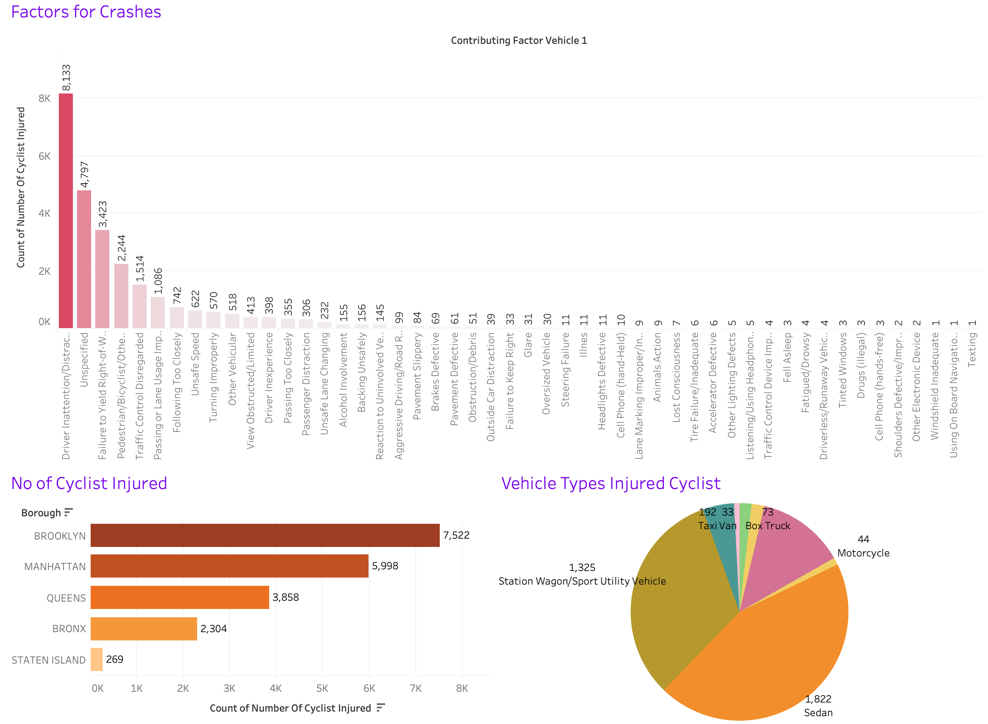

**Interpretation –**

Actionable insights are revealed by the dashboard: inattentive driving is the main cause of cycling accidents, which are concentrated in boroughs with high population densities during peak traffic periods. Large passenger cars like SUVs and sedans are involved, which emphasizes the need for more bike lanes with protection and for initiatives to raise awareness among drivers.

These results will serve as a roadmap for future safety recommendations and public initiatives targeted at lowering the number of bike fatalities and injuries.